*The Product Company*

~ Final Data Mart Development Report ~

Team # ____2_____

Team Members

_________________Sidhartha Amperayani________________

____________________Vibhuti Bansal___________________

____________________Jairaj Pisupati____________________

December 5th, 2021

ISTE-DW Data Warehousing

~ Table of Contents ~

I. Data Mart Design Definition 2

1. Universe of Discourse 2

2. Information Package 2

II. Dimensional Model 3

III. Data Staging: ETL – Data Extract File Definitions 4

IV. Data Staging: ETL – Source-to-Target Mappings 5

V. SQL Code – Tables & Constraints 6

VI. Data Staging Activities - ETL 7

1. Data Cleansing 7

2. Data Transformation 7

3. Table Population 7

VII. End User Applications 8

1. SQL99 Queries 8

2. A Views 8

3. Aggregated Data Marts …….……………………………………………...................9

VIII. Handling Slowly Changing Dimensions (SCD)……..…………………………. 10

IX. N-M Implementation Option………………………………………………….…11

X Appendix (Fix Lab #3)…………………………………………………………..12

# I. Data Mart Design Definition

## 1. Universe of Discourse

|  |
| --- |
| The scope of the data mart is to help TPC management analyze and optimize their financial performance at the gross profit (margin) level historically, reduce costs and manage their relationships with suppliers better.  TPC management can analyze the amount of profit (profit = sales - cost) or sales made by TPCE, TPCW, and PEC yearly/quarterly/monthly/weekly/daily based on product/product category or customer/customer type for Decision support. Through keeping track of how long the manufacturing is taking, the order is being shipped, how many sales are being recorded; how much quantity is being ordered, etc. based on daily, weekly, monthly, quarterly, yearly analysis. This would help the company to improve the efficiency of the operations and help improve sales. |

## 2. Information Package

Process Name: ___Financial Control and Analysis___

Grain: ___Individual Product Sale record ___

|  |  |  |  |  |  |
| --- | --- | --- | --- | --- | --- |
| Customer Dim | Order Date Dim | Sales Date Dim | Product Dim | Supplier Dim | Options Junk Dim |
| Customer SK | Order Date SK | Sales Date SK | Product SK | Supplier SK | Options SK |
| Customer ID(NK) | Fiscal Year | Fiscal Year | Product ID (NK) | Supplier ID (NK) | Transport Method |
| Customer Type | Fiscal Quarter | Fiscal Quarter | Product Type Desc. | Supplier Name | Payment Method |
| Customer Name | Fiscal Month | Fiscal Month | Product Desc. | Address 1 | Ordering Method |
| Address 1 | Fiscal Week | Fiscal Week | Business Name | Address 2 |  |
| Address 2 | Fiscal Day | Fiscal Day | Business Abbrev. | State |  |
| State | Calendar Year | Calendar Year | Price 1 | City |  |
| City | Calendar Quarter | Calendar Quarter | Price 2 | Zip |  |
| Zip | Calendar Month | Calendar Month | Unit Cost | Company |  |
| Company | Calendar Week | Calendar Week | Company |  |  |
|  | Calendar Day | Calendar Day |  |  |  |
|  | Order Date | Sales Date |  |  |  |

Facts: __Quantity, Cost, Profit, Transportation Cost, Sales, Discounted, Invoice ID(DD)__

3. Entity Definitions

Entity Name: Customer Dimension

Entity Definition: Customer dimension has details of customers from all 3 divisions (TPC-E, TPC-W, PEC).PEC. Customer Dimension has the details of all the customers who have purchased from any of the 3 divisions.

|  |  |  |  |
| --- | --- | --- | --- |
| Entity | Attribute Name | Attribute Data Type | Attribute Description |
| Customer Dimension | Customer_SK | INT | Surrogate key for the Customer |
| Customer_ID(NK) | INT | Natural Key for the Customer. |
| Customer_Type | VARCHAR | Customer Type Description. |
| Customer Name | VARCHAR | Name of the Customer. |
| Addr1 | VARCHAR | Address line 1 of the Customer. |
| Addr1 | VARCHAR | Address line 1 of the Customer. |
| State | VARCHAR | State that the Customer belongs to |
| City | VARCHAR | City that the Customer belongs to. |
| Zip | CHAR | Zip Code of the Customer. |
| Company | VARCHAR | The Division (TPC-E, TPC-W, PEC) that the Customer is affiliated to. |

Entity Name: Product Dimension

Entity Description: This table consists of the product details including the Unit Cost, Selling Price, Discounted Price, etc. This table is useful for calculating profit.

|  |  |  |  |
| --- | --- | --- | --- |
| Entity | Attribute Name | Attribute Data Type | Attribute Description |
| Product Dimension | Product_SK | INT | Surrogate key for the Product |
| Product_ID(NK) | INT | Natural Key for the Product. |
| Product_Type_Description | VARCHAR | Product Type Description. |
| Product Description | VARCHAR | Name of the Product. |
| Business_Name | VARCHAR | The Business that the product is affiliated with. |
| Business_Abbrev | VARCHAR | The Abbreviation of the Affiliated Business. |
| Price 1 | DECIMAL | The standard price of the product per unit. |
| Price 2 | DECIMAL | The discounted price of the product per unit |
| Unit_Cost | DECIMAL | The standard cost of the product per unit. |
| Company | VARCHAR | The Division (TPC-E, TPC-W, PEC) that the Product is affiliated to. |

# 

Entity Name: Supplier Dimension

Entity Description: This table consists of the supplier details.

|  |  |  |  |
| --- | --- | --- | --- |
| Entity | Attribute Name | Attribute Data Type | Attribute Description |
| Supplier Dimension | Supplier_SK | INT | Surrogate key for the Supplier. |
| Supplier_ID(NK) | INT | Natural Key for the Supplier. |
| Supplier_Name | VARCHAR | Name of the Supplier. |
| Addr1 | VARCHAR | The first address line of the supplier. |
| Addr2 | VARCHAR | The second address line of the supplier. |
| City | VARCHAR | The city of the supplier. |
| State | VARCHAR | The official USPS state abbreviation. |
| Zip | CHAR | The 5 digit USPS zip code. |
| Company | VARCHAR | The Division (TPC-E, TPC-W, PEC) that the Product is affiliated to. |

Entity Name: Order Date Dimension

Entity Description: This table consists of all possible Order Dates.

|  |  |  |  |
| --- | --- | --- | --- |
| Entity | Attribute Name | Attribute Data Type | Attribute Description |
| Order Date Dimension | Order_Date_SK | INT | Surrogate key for the Order Date. |
| Fiscal_Year | INT | Fiscal Year of the Order. |
| Fiscal_Quarter | INT | Fiscal Quarter of the Order. |
| Fiscal_Month | INT | Fiscal Month of the Order. |
| Fiscal_Week | INT | Fiscal Week of the Order. |
| Fiscal_Day | INT | Fiscal Day of the Order. |
| Calendar_Year | INT | Calendar Year of the Order. |
| Calendar_Quarter | INT | Calendar Quarter of the Order. |
| Calendar_Month | INT | Calendar Month of the Order. |
| Calendar_Week | INT | Calendar Week of the Order. |
| Calendar_Day | INT | Calendar Day of the Order. |
| Order_Date | DATETIME | Date of the Order |

# 

Entity Name: Sales Date Dimension

Entity Description: This table consists of all possible Sale Dates.

|  |  |  |  |
| --- | --- | --- | --- |
| Entity | Attribute Name | Attribute Data Type | Attribute Description |
| Sales Date Dimension | Sales_Date_SK | INT | Surrogate key for the Sales Date. |
| Fiscal_Year | INT | Fiscal Year of the Sale. |
| Fiscal_Quarter | INT | Fiscal Quarter of the Sale. |
| Fiscal_Month | INT | Fiscal Month of the Sale. |
| Fiscal_Week | INT | Fiscal Week of the Sale. |
| Fiscal_Day | INT | Fiscal Day of the Sale. |
| Calendar_Year | INT | Calendar Year of the Sale. |
| Calendar_Quarter | INT | Calendar Quarter of the Sale. |
| Calendar_Month | INT | Calendar Month of the Sale. |
| Calendar_Week | INT | Calendar Week of the Sale. |
| Calendar_Day | INT | Calendar Day of the Sale. |
| Sales_Date | DATETIME | Date of the Sale |

# 

Entity Name: Options Junk Dimension

Entity Description: This table consists of all possible Options for Payment, Transportation, and Ordering of an Order.

|  |  |  |  |
| --- | --- | --- | --- |
| Entity | Attribute Name | Attribute Data Type | Attribute Description |
| Options_Junk | Options_SK | INT | Surrogate Key of the options junk table. |
| Transport_Method | VARCHAR | Method Used for Transporting the Order. |
| Payment_Method | VARCHAR | Method Used for Paying the Order. |
| Ordering_Method | VARCHAR | Method Used for placing the Order. |

# 

Entity Name: Financial Analysis Dimension

Entity Description: This is the fact table and it consists of all the foreign keys connecting to the other dimension tables and contains other facts relevant for analysis.

|  |  |  |  |
| --- | --- | --- | --- |
| Entity | Attribute Name | Attribute Data Type | Attribute Description |
| Financial Analysis Fact | Customer_SK | INT | Surrogate Key of the Customer table. |
| Product_SK | INT | Surrogate Key of the Product table. |
| Supplier_SK | INT | Surrogate Key of the Supplier table. |
| Sales_Date_SK | INT | Surrogate Key of the Sales Date table. |
| Order_Date_SK | INT | Surrogate Key of the Order Date table. |
| Options_Junk_SK | INT | Surrogate Key of the Options Junk table. |
| Quantity | DECIMAL | Quantity purchased. |
| Cost | DECIMAL | Cost of purchase. |
| Profit | DECIMAL | Profit from that purchase. Profit = Sales - Cost |
| Tranportation_Cost | DECIMAL | Cost to transport the order. |
| Sales | DECIMAL | Cost at which the order was purchased by the customer. |
| Discounted | TINYINT | Whether the customer availed the purchase at a discount or not. 1 -> discount and 0->No discount. |
| Invoice_ID | INT | The invoice ID of the purchase. |

# 

# II. Dimensional Model

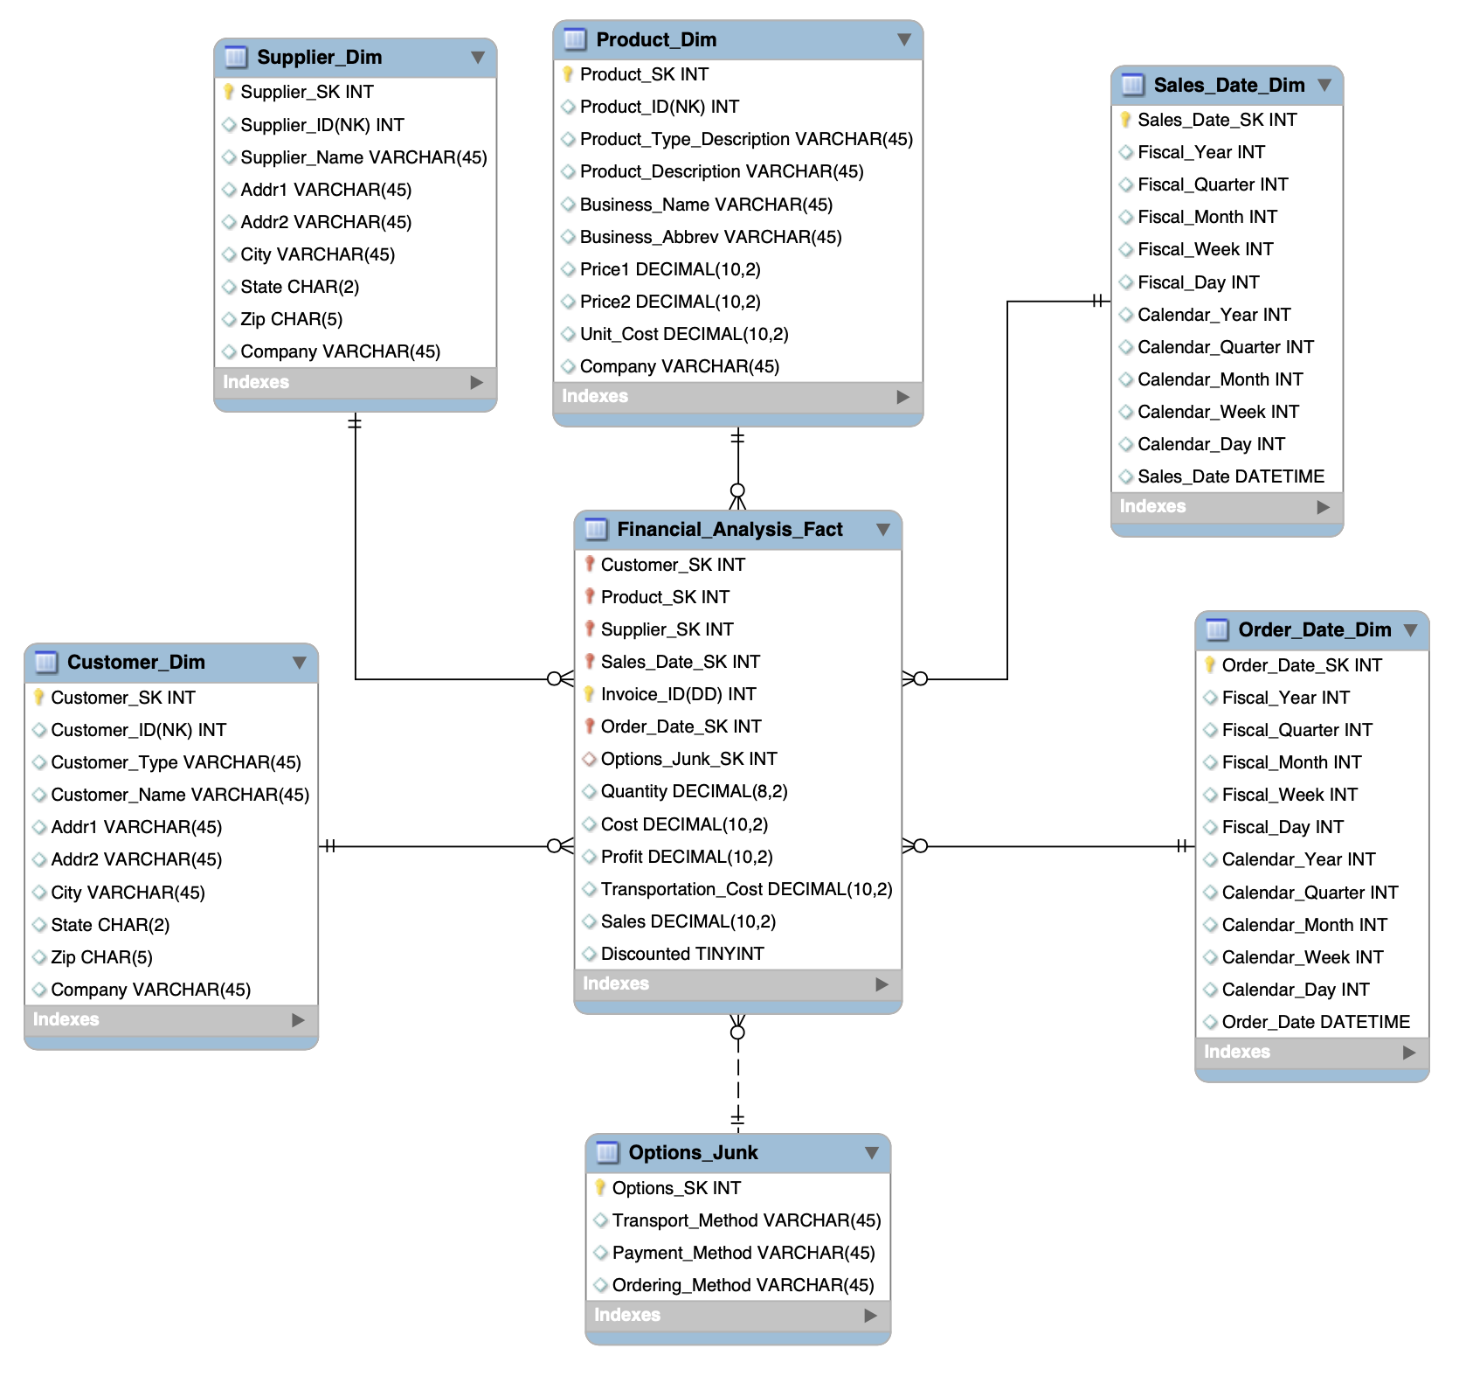

# 

# The above diagram is the Entity Relation Diagram for the Financial Analysis Data Mart. It contains 1 Fact table, 5 Dimension Tables, and 1 Junk Dimension.

In the Fact table, we measure facts like Quantity, Unit Cost, Cost, Profit, Transportation Cost, Sales, and Discounted.

# 

# Customer Dimension Table

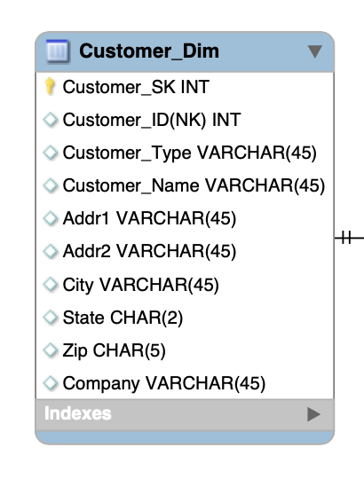

**Product Dimension Table**

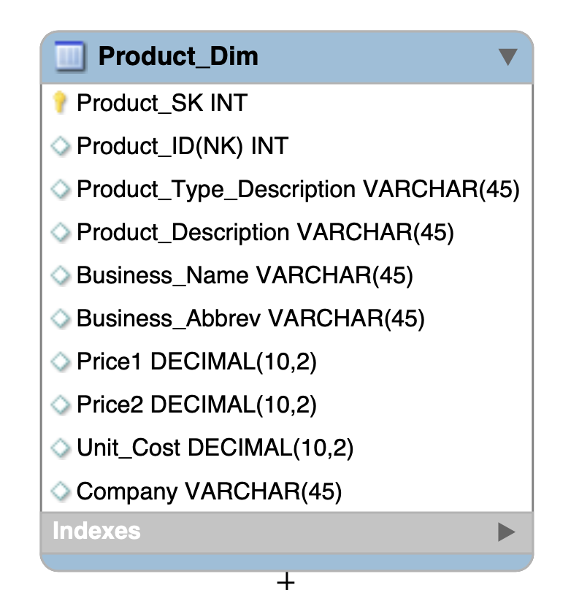

**Supplier Dimension Table**

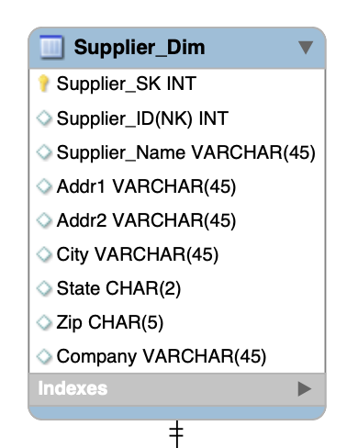

**Order Date Dimension Table**

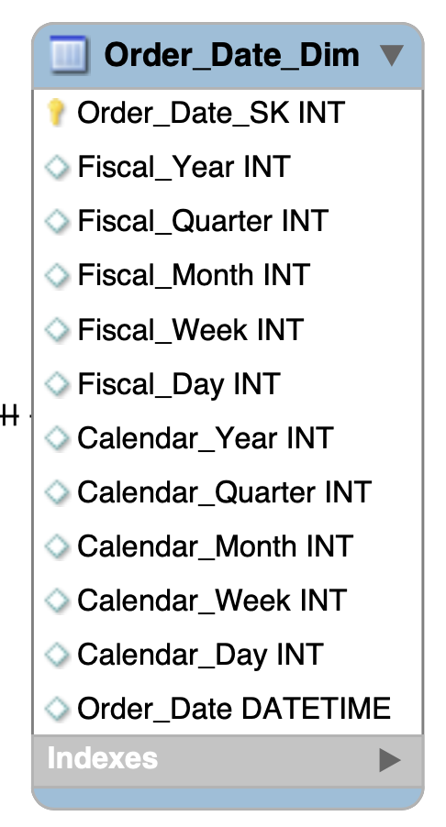

**Junk Dimension Table**

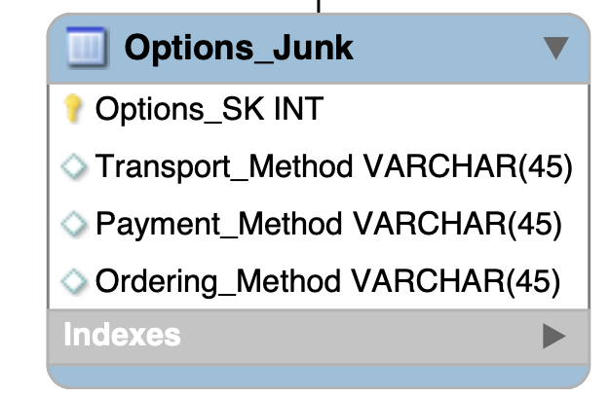

**Sales Date Dimension Table**

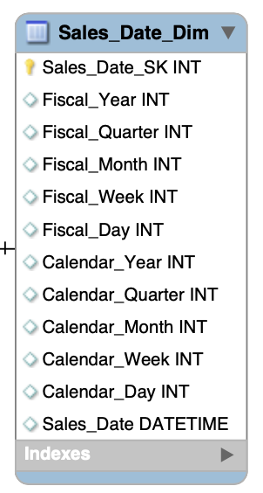

**Financial Analysis Fact Table**

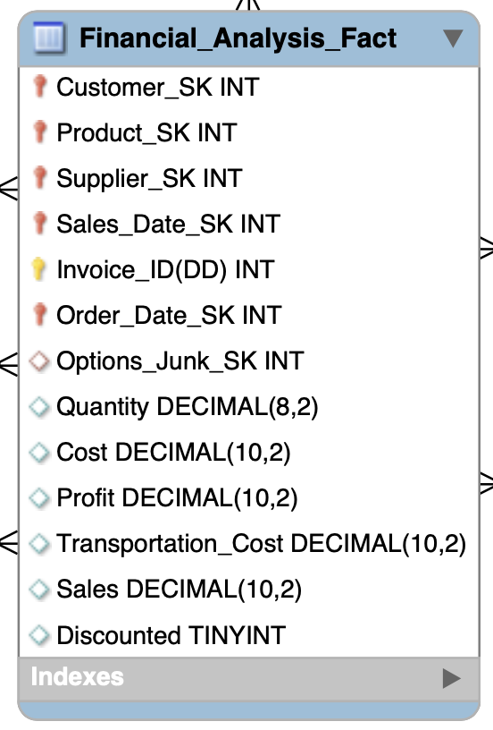

# III. Data Staging: ETL – Data Extract File Definitions

|  |  |  |  |
| --- | --- | --- | --- |
| Dimension | Company | Entity Name | Source (.Format) |
| Customer Dimension | TPC-E | Customer | customer.csv |
| Customer Type | customer_type.csv |
| TCPW | TPC_W_Customer | TPCWcustomer.csv |
| TPC_W_Customer_type | TPCWcustomer_type.csv |
| PEC | PEC Customer | PECcustomer.csv |
| PEC Customer Type | PECcustomer_type.csv |

|  |  |  |  |
| --- | --- | --- | --- |
| Dimension | Company | Entity Name | Source (.Format) |
| Product Dimension | TPC-E | Product | product.csv |
| Product Type | prod_type.csv |
| Business Unit | business_unit.csv |
| TPC-W | TPC_W_product | TPCWproduct.csv |
| TPC_W_Product_type | TPCWproduct_type.csv |
| TPC_W_BU | TPCWbusiness_unit.csv |
| PEC | PEC Product | PECProduct.csv |
| PEC Product Type | PECproduct_type.csv |
| PEC Business Unit | PECbusiness_unit.csv |
| PEC Product Unit cost | PECmanufacturingCosts.csv |

|  |  |  |  |
| --- | --- | --- | --- |
| Dimension | Company | Entity Name | Source (.Format) |
| Supplier  Dimension | TPC-E | Supplier | supplier.csv |
| TPC-W | supplier_dim | TPCWproduct.csv |
| PEC | PEC Supplier Name | PECproduct.csv |

|  |  |  |  |
| --- | --- | --- | --- |
| Dimension | Company | Entity Name | Source (.Format) |
| Order Date Dimension | TPC-E | N/A | N/A |
| TPC-W | N/A | N/A |
| PEC | PEC Order Date | PECinvoice.csv |

|  |  |  |  |
| --- | --- | --- | --- |
| Dimension | Company | Entity Name | Source (.Format) |
| Sales Date Dimension | TPC-E | TPCE Sales Date | invoice.csv |
| TPC-W | TPCW_Invoice | TPCWinvoice.csv |
| PEC | PEC Sales Date | PECinvoice.csv |

|  |  |  |  |
| --- | --- | --- | --- |
| Dimension | Company | Entity Name | Source (.Format) |
| Junk Dimension | TPC-E | N/A | N/A |
| TPC-W | N/A | N/A |
| PEC | PEC Options_Junk | PECinvoice.csv |

|  |  |  |  |
| --- | --- | --- | --- |
| Dimension | Company | Entity Name | Source (.Format) |
| Financial Analysis Fact | TPC-E | TPCE Invoice | invoice.csv |
| invoice_detail.csv |
| TPC-W | TPCW Invoice | TPCWinvoice.csv |
| PEC | PEC Invoice | PECinvoice.csv |

# 

# 

# 

# IV. Data Staging: ETL – Source-to-Target Mappings

Follow the same format as indicated in “The Data Warehouse ETL Toolkit” by Kimball & Caserta, Fig. 3.1 on page 60. This is available on Books 24x7. The table should be in alphabetical order table name and column name.

|  |  |  |  |  |  |  |  |  |  |
| --- | --- | --- | --- | --- | --- | --- | --- | --- | --- |
| **Target** | | | | | **Source** | | | | **Transformation** |
| **Table Name** | **Column Name** | **Data Type** | **Table Type** | **SCD Type** | **Database Name** | **Table Name** | **Column Name** | **Data**  **Type** |  |
| OrderDate Dim | Order  Date_SK | INT | Dimension | SCD Type 0 | PEC |  |  |  | Surrogate Key is generated using the add sequence in Pentaho. |
| OrderDate Dim | Calendar_Year | INT | Dimension | SCD Type 0 | PEC | PEC  invoice | Order  Date | INT | Extracted orderDate from invoice using Pentaho. Calculated calendar year from orderDate using ‘Year of Date A’ in Calculator in Pentaho. |
| OrderDate Dim | Calendar_Quarter | INT | Dimension | SCD Type 0 | PEC | PECinvoice | orderDate | INT | Extracted orderDate from invoice using Pentaho. Calculated calendar year from orderDate using ‘Quarter of Date A’ in Calculator in Pentaho. |
| OrderDate Dim | Calendar_Month | INT | Dimension | SCD Type 0 | PEC | PECinvoice | orderDate | INT | Extracted orderDate from invoice using Pentaho. Calculated calendar year from orderDate using ‘Month of Date A’ in Calculator in Pentaho. |
| OrderDate Dim | Calendar_Week | INT | Dimension | SCD Type 0 | PEC | PECinvoice | orderDate | INT | Extracted orderDate from invoice using Pentaho. Calculated calendar year from orderDate using ‘Week of year of Date A’ in Calculator in Pentaho. |
| OrderDate Dim | Calendar_Day | INT | Dimension | SCD Type 0 | PEC | PECinvoice | orderDate | INT | Extracted orderDate from invoice using Pentaho. Calculated calendar day from orderDate using ‘Day of Month of Date A’ in Calculator in Pentaho. |
| OrderDate Dim | Fiscal_Year | INT | Dimension | SCD Type 0 | PEC | PECinvoice | orderDate | INT | Extracted orderDate from invoice using Pentaho. Calculated fiscal year from orderDate using Javascript function in Pentaho. |
| OrderDate Dim | Fiscal_Quarter | INT | Dimension | SCD Type 0 | PEC | PECinvoice | orderDate | INT | Extracted orderDate from invoice using Pentaho. Calculated fiscal quarter from orderDate using Javascript function in Pentaho. |
| OrderDate Dim | Fiscal_Month | INT | Dimension | SCD Type 0 | PEC | PECinvoice | orderDate | INT | Extracted orderDate from invoice using Pentaho. Calculated fiscal month from orderDate using Javascript function in Pentaho. |
| OrderDate Dim | Fiscal_Week | INT | Dimension | SCD Type 0 | PEC | PECinvoice | orderDate | INT | Extracted orderDate from invoice using Pentaho. Calculated fiscal week from orderDate using Javascript function in Pentaho. |
| OrderDate Dim | Fiscal_Day | INT | Dimension | SCD Type 0 | PEC | PECinvoice | orderDate | INT | Extracted orderDate from invoice using Pentaho. Calculated fiscal day from orderDate using Javascript function in Pentaho. |
| OrderDate Dim | OrderDate | DATETIME | Dimension | SCD Type 0 | PEC | PECinvoice | orderDate | DATE | Extracted year, month, and day of orderDate from invoice using Pentaho. |

|  |  |  |  |  |  |  |  |  |  |
| --- | --- | --- | --- | --- | --- | --- | --- | --- | --- |
| **Target** | | | | | **Source** | | | | **Transformation** |
| **Table Name** | **Column Name** | **Data Type** | **Table Type** | **SCD Type** | **Database Name** | **Table Name** | **Column Name** | **Data**  **Type** |  |
| SalesDate Dim | Sales_Date_SK | INT | Dimension | SCD Type 0 |  |  |  |  | Surrogate Key is generated using the add sequence in Pentaho. |
| SalesDate Dim | Sales Date | DATETIME | Dimension | SCD Type 0 | PEC | PECinvoice | salesDate | INT | Extracted year, month, and day of salesDate from invoice using Pentaho. |
| SCD Type 0 | TPCW | TPCW_Invoice | sales_date_dim | INT | Using Pentaho conformed the date format, type and length to 8; extracted all the unique dates from TPCW_invoice. Calculated calendar year, quarter, month, week and day using calculator step. Using javascript step calculated fiscal counterparts of above mentioned. |
| SCD Type 0 | TPCE | invoice | salesDate | INT | Extracted salesDate from invoice using Pentaho. Calculated date, month and year from salesDate using Calculator in Pentaho. |
| SalesDate Dim | Calendar Year | INT | Dimension | SCD Type 0 | PEC | PECinvoice | salesDate | INT | Extracted salesDate from invoice using Pentaho. Calculated calendar year from salesDate using ‘Year of Date A’ in Calculator in Pentaho. |
| SCD Type 0 | TPCW | TPCW_Invoice | sales_date_dim | INT | Calculated calander year, quarter, month, week and day using calculator step. Using javascript step calculated fiscal counterparts of above mentioned. |
| SCD Type 0 | TPCE | Invoice | salesDate | INT | TPCE Year Extraction from SalesDate using Calculator in PENTAHO. |
| SalesDate Dim | Calendar Quarter | INT | Dimension | SCD Type 0 | PEC | PECinvoice | salesDate | INT | Extracted salesDate from invoice using Pentaho. Calculated calendar quarter from salesDate using Quarter of Date A’ in Calculator in Pentaho. |
| SCD Type 0 | TPCW | TPCWinvoice | salesDate | INT | Calculated calander year, quarter, month, week and day using calculator step. Using javascript step calculated fiscal counterparts of above mentioned. |
| SCD Type 0 | TPC-E | invoice | salesDate | INT | TPCE Quarter Extraction from SalesDate using Calculator in PENTAHO |
| SalesDate Dim | Calendar Month | INT | Dimension | SCD Type 0 | PEC | PECinvoice | salesDate | INT | Extracted salesDate from invoice using Pentaho. Calculated calendar year from salesDate using ‘Month of Date A’ in Calculator in Pentaho. |
| SCD Type 0 | TPCW | TPCWinvoice | salesDate | INT | Calculated calander year, quarter, month, week and day using calculator step. Using javascript step calculated fiscal counterparts of above mentioned. |
| SCD Type 0 | TPC-E | invoice | salesDate | INT | TPCE Month Extraction from SalesDate using Calculator in PENTAHO. |
| SalesDate Dim | Calendar Week | INT | Dimension | SCD Type 0 | PEC | PECinvoice | salesDate | INT | Extracted salesDate from invoice using Pentaho. Calculated calendar year from salesDate using ‘Week of year of Date A’ in Calculator in Pentaho. |
| SCD Type 0 | TPCW | TPCWinvoice | salesDate | INT | Calculated calander year, quarter, month, week and day using calculator step. Using javascript step calculated fiscal counterparts of above mentioned. |
| SCD Type 0 | TPC-E | invoice | salesDate | INT | TPCE Week Extraction from SalesDate using Calculator in PENTAHO. |
| SalesDate Dim | Calendar Day | INT | Dimension | SCD Type 0 | PEC | PECinvoice | salesDate | INT | Extracted salesDate from invoice using Pentaho. Calculated calendar day from salesDate using ‘Day of Month of Date A’ in Calculator in Pentaho. |
| SCD Type 0 | TPCW | TPCWinvoice | salesDate | INT | Calculated calander year, quarter, month, week and day using calculator step. Using javascript step calculated fiscal counterparts of above mentioned. |
| SCD Type 0 | TPCE | invoice | salesDate | INT | TPCE Day Extraction from SalesDate using Calculator in PENTAHO. |
| SalesDate Dim | FiscalYear | INT | Dimension | SCD Type 0 | PEC | PECinvoice | salesDate | INT | Extracted salesDate from invoice using Pentaho. Calculated fiscal year from calendar year using Javascript function in Pentaho. |
| SCD Type 0 | TPCW | TPCWinvoice | salesDate | INT | Calculated calander year, quarter, month, week and day using calculator step. Using javascript step calculated fiscal counterparts of above mentioned. |
| SCD Type 0 | TPCE | invoice | salesDate | INT | TPCE Year Extraction from SalesDate using Calculator in PENTAHO.Then using Javascript to convert Calendar Year to Fiscal Year. |
| SalesDate Dim | FiscalQuarter | INT | Dimension | SCD Type 0 | PEC | PECinvoice | salesDate | INT | Extracted salesDate from invoice using Pentaho. Calculated fiscal quarter from calendar quarter using Javascript function in Pentaho. |
| TPCW | TPCWinvoice | salesDate | INT | Calculated calander year, quarter, month, week and day using calculator step. Using javascript step calculated fiscal counterparts of above mentioned. |
| TPCE | invoice | salesDate | INT | TPCE Quarter Extraction from SalesDate using Calculator in PENTAHO.  Then using Java script to convert Calendar Quarter to Fiscal Quarter. |
| SalesDate Dim | FiscalMonth | INT | Dimension | SCD Type 0 | PEC | PECinvoice | salesDate | INT | Extracted salesDate from invoice using Pentaho. Calculated fiscal month from calendar month using Javascript function in Pentaho. |
| SCD Type 0 | TPCW | TPCWinvoice | salesDate | INT | Calculated calander year, quarter, month, week and day using calculator step. Using javascript step calculated fiscal counterparts of above mentioned. |
| SCD Type 0 | TPCE | invoice | salesDate | INT | TPCE Month Extraction from SalesDate using Calculator in PENTAHO. Then using Javascript to convert Calendar Month to Fiscal Month. |
| SalesDate Dim | FiscalWeek | INT | Dimension | SCD Type 0 | PEC | PECinvoice | salesDate | INT | Extracted salesDate from invoice using Pentaho. Calculated fiscal week from calendar week using Javascript function in Pentaho. |
| TPCW | TPCWinvoice | salesDate | INT | Calculated calander year, quarter, month, week and day using calculator step. Using javascript step calculated fiscal counterparts of above mentioned. |
| TPCE | invoice | salesDate | INT | TPCE Week Extraction from SalesDate using Calculator in PENTAHO. Then using Javascript to convert Calendar Week to Fiscal Week. |
| SalesDate Dim | FiscalDay | INT | Dimension | SCD Type 0 | PEC | PECinvoice | salesDate | INT | Extracted salesDate from invoice using Pentaho. Calculated fiscal day from calendar day using Javascript function in Pentaho. |
| TPCW | TPCWinvoice | salesDate | INT | Calculated calander year, quarter, month, week and day using calculator step. Using javascript step calculated fiscal counterparts of above mentioned. |
| TPCE | invoice | salesDate | INT | TPCE Day Extraction from SalesDate using Calculator in PENTAHO. Then using Javascript to convert Calendar Day to Fiscal Day. |

|  |  |  |  |  |  |  |  |  |  |
| --- | --- | --- | --- | --- | --- | --- | --- | --- | --- |
| **Target** | | | | | **Source** | | | | **Transformation** |
| **Table Name** | **Column Name** | **Data Type** | **Table Type** | **SCD Type** | **Database Name** | **Table Name** | **Column Name** | **Data**  **Type** |  |
| Financial_Analysis Fact | Qty | DECIMAL(8,2) | Fact | SCD Type 1 | PEC | PECinvoice | qty | Decimal | Mapped from CSV to Fact using Pentaho. Set Qty = 1 if the qty was found to be null. |
| TPCW | TPCWinvoice | Quantity | Decimal | Mapped from CSV to Fact using Pentaho. |
| TPCE | invoice_details | Quantity | Decimal | Mapped from CSV to Fact using Pentaho. |
| Financial_Analysis Fact | Discounted | TINYINT | Fact | SCD Type 1 | PEC | PECinvoice | discounted | Boolean | Converted to Boolean value using Pentaho. |
| TPCW | TPCWinvoice | discounted | INT | Converted to Boolean value using Pentaho. |
| TPCE | invoice_details | discounted | Boolean | Converted to Boolean value using Pentaho. |
| Financial_Analysis Fact | Invoice_ID(DD) | INT | Fact | SCD Type 0 | PEC | PECinvoice | Invoice | INT | Mapped from CSV file to Fact using Pentaho. |
| TPCW | TPCWinvoice | invoice | INT | Mapped from CSV file to Fact using Pentaho. |
| TPCE | invoice_details | invoice_ID(DD) | INT | Mapped from CSV file to Fact using Pentaho. |
| Financial_Analysis Fact | Cost | DECIMAL(10,2) | Fact | SCD Type 1 | PEC | PECinvoice; PECproduct, PECmanufacturingCosts | qty; unitCost; manufacturingCost | Number | The product of Quantity and Unit_Cost of that Product. Cost = Unit_Cost * Quantity. For products with null unit_cost, we calculated the unit_cost for each product using manufacturingCost. |
| TPCW | TPCWinvoice | amt & qty | Number | The product of Quantity and Unit_Cost of that Product. Cost = Unit_Cost * Quantity |
| TPCE | invoice_details | Unit_Cost and Quantity | Decimal | The product of Quantity and Unit_Cost of that Product. Cost = Unit_Cost * Quantity |
| Financial_Analysis Fact | Transportation Cost | DECIMAL(10,2) | Fact |  | PEC | PECinvoice | shipCost | Decimal | No Change |
| TPCW | NA | NA | NA | NA |
| TPCE | NA | NA | NA | NA |
| Financial_Analysis Fact | Sales | DECIMAL(10,2) | Fact |  | PEC | PECProduct; PECinvoice | price1, price2; discounted | Decimal | The product of Quantity and price of that Product. Sales = price1 * qty if discounted is 0, otherwise Sales = price2 * qty when discounted = 1 |
|  | TPCW | invoice_details | amt | Decimal | We map the amt field from the CSV to the Sales |
|  | TPCE | invoice_details | amt | Decimal | We map the amt field from the CSV to the Sales |
| Financial_Analysis Fact | Profit | DECIMAL(10,2) | Fact |  | PEC | PECProduct; PECinvoice | Sales; Cost | Decimal | Calculated profit using the formula: Profit = Sales - Cost |
|  | TPCW | product | unitcost | Decimal | Subtract the cost from the sales. profit = sales - cost. |
|  | TPCE | product | unitcost | Decimal | Subtract the cost from the sales. profit = sales - cost. |

|  |  |  |  |  |  |  |  |  |  |
| --- | --- | --- | --- | --- | --- | --- | --- | --- | --- |
| **Target** | | | | | **Source** | | | | **Transformation** |
| **Table Name** | **Column Name** | **Data Type** | **Table Type** | **SCD Type** | **Database Name** | **Table Name** | **Column Name** | **Data**  **Type** |  |
| Customer_Dim | Customer_SK | INT | Dimension | SCD Type 0 | - | - | - | INT | Surrogate Key is generated using the add sequence in Pentaho. |
|  | Customer_ID(NK) | INT | Dimension | SCD Type 0 | PEC | PEC customer | custID | INT | Mapped the natural key in PEC Customer Dimension using Pentaho |
|  |  |  |  |  | TPC-W | customer | CUSTID | INT | We map the Customer ID from the CSV to the Customer Dimension Table using Pentaho |
|  |  |  |  |  | TPCE | customer | CUSTID | INT | We map the Customer ID from the CSV to the Customer Dimension Table using Pentaho |
|  | Customer_Name | VARCHAR(45) | Dimension | SCD Type 0 | PEC | PEC customer | name | string | Transfomed Corporation to Corp., Incorporated to Inc., etc for consistency. |
|  |  |  |  |  | TPC-W | TPC-W customer | name | string | Transfomed Corporation to Corp., Incorporated to Inc., etc for consistency |
|  |  |  |  |  | TPCE | customer | Customer_Name | string | Customer Names are mapped from the CSV file to the Dimension table using Pentaho. |
|  | Addr1 | VARCHAR(45) | Dimension | SCD Type 0 | PEC | PEC customer | address | string | Mapped PEC address field into Addr1. |
|  |  |  |  |  | TPC-W | TPC-W customer | address | string | created a new column Addr 2 and was filled accordingly, conformed with other information |
|  |  |  |  |  | TPCE | customer | Addr1 | string | Customer Addresses are mapped from the CSV file to the Dimension table using Pentaho. |
|  | Addr2 | VARCHAR(45) | Dimension | SCD Type 0 | PEC | PEC customer | address | string | - |
|  |  |  |  |  | TPC-W | TPC-W customer | address | string | created a new column Addr 2 and was filled accordingly, conformed with other information |
|  |  |  |  |  | TPCE | customer | Addr2 | string | Customer Addresses are mapped from the CSV file to the Dimension table using Pentaho. |
|  | city | VARCHAR(45) | Dimension | SCD Type 0 | PEC | PEC customer | city | string | Mapped the field to city attribute using Pentaho. |
|  |  |  |  |  | TPC-W | TPC- W customer | city | string | Mapped the field to city attribute using Pentaho. |
|  |  |  |  |  | TPCE | customer | city | string | Customer’s City are mapped from the CSV file to the Dimension table using Pentaho. |
|  | state | CHAR(2) | Dimension | SCD Type 0 | PEC | PEC customer | state | string | Mapped the field to city attribute using Pentaho. |
|  |  |  |  |  | TPC-W | TPC-W customer | state | string | Customer’s state are mapped from the CSV file to the Dimension table using Pentaho. |
|  |  |  |  |  | TPCE | customer | state | string | Customer’s state are mapped from the CSV file to the Dimension table using Pentaho. |
|  | zip | CHAR(5) | Dimension | SCD Type 0 | PEC | PEC customer | zip | char(5) | Customer’s Zips are mapped from the CSV file to the Dimension table using Pentaho. They are inserted as char(5). Additional left zero padding is added if it is less than 5 characters long. |
|  |  |  |  |  | TPC-W | TPC-W customer | zip | char(5) | Customer’s Zips are mapped from the CSV file to the Dimension table using Pentaho. They are inserted as char(5). Additional left zero padding is added if it is less than 5 characters long. |
|  |  |  |  |  | TPCE | customer | Zip | string | Customer’s Zips are mapped from the CSV file to the Dimension table using Pentaho. They are inserted as char(5). Additional left zero padding is added if it is less than 5 characters long. |
|  | Customer_Type | VARCHAR(20) | Dimension | SCD Type 0 | PEC | PEC customer_type & PEC customer | custtype, TYPENAME | string | The field values in the csv are cleaned and mapped to the attribute in the Customer dimension using Pentaho. Transformed for consistency. |
|  |  |  |  |  | TPC-W | TPC-Wcustomer_type & TPCWcustomer | custtype, TYPENAME | string | Customer type id was used to merge the customer.csv and the customer_type.csv to get the customer type name. |
|  |  |  |  |  | TPCE | customer_type | TYPENAME | string | Customer type id was used to merge the customer.csv and the customer_type.csv to get the customer type name. |
|  | Company | VARCHAR(45) | Dimension | SCD Type 0 | PEC | PEC customer_type | CUSTTYPEID | INT | Generated using Pentaho Calculator. |
|  |  |  |  |  | TPCW | TPC-W customer_type | CUSTTYPEID | INT | Generated using Pentaho Calculator. |
|  |  |  |  |  | TPCE | NA | NA | string | Generated using Pentaho Calculator. |

|  |  |  |  |  |  |  |  |  |  |
| --- | --- | --- | --- | --- | --- | --- | --- | --- | --- |
| **Target** | | | | | **Source** | | | | **Transformation** |
| **Table Name** | **Column Name** | **Data Type** | **Table Type** | **SCD Type** | **Database Name** | **Table Name** | **Column Name** | **Data**  **Type** |  |
| Product | Product_SK | INT | Dimension | SCD Type 0 |  |  |  |  | Surrogate Key is generated using the add sequence in Pentaho. |
| Product | Product_ID(NK) | INT | Dimension | SCD Type 0 | PEC | PEC product | prodid | INT | Mapped the natural key in PEC Product Dimension using Pentaho |
|  |  |  |  |  | TPC-W | TPC-W product | PRODIDr | INT | Pentaho is used to map the Product_Id from the csv file to the Dimension table. |
|  |  |  |  |  | TPCE | product | PRODID | INT | Pentaho is used to map the Product_Id from the csv file to the Dimension table. |
| Product | Product_Description | VARCHAR(45) | Dimension | SCD Type 1 | PEC | PEC product | prodDescription | string | Cleaning such as removing the double quotes is performed and then mapped to the dimension attribute. |
|  |  |  |  |  | TPC-W | TPC-W product | DESCRIPTION | string | After cleaning the Product Description is taken from the product CSV file and mapped to the Dimension table. |
|  |  |  |  |  | TPCE | product | DESCRIPTION | string | After cleaning the Product Description is taken from the product CSV file and mapped to the Dimension table. |
| Product | Price1 | DECIMAL(10,2) | Dimension | SCD Type 2 | PEC | PEC product | price1 | Decimal | After Cleaning the Price 1 field from the product csv is mapped to the price 1 in the product dimension table |
|  |  |  |  |  | TPCW | TPC-W product | price1 | Decimal | After Cleaning the Price 1 field from the product csv is mapped to the price 1 in the product dimension table |
|  |  |  |  |  | TPCE | product | PRICE1 | Decimal | After Cleaning the Price 1 field from the product csv is mapped to the price 1 in the product dimension table |
| Product | Price2 | DECIMAL(10,2) | Dimension | SCD Type 2 | PEC | PEC product | price2 | Decimal | After Cleaning the Price 2 field from the product csv is mapped to the price 2 in the product dimension table |
|  |  |  |  |  | TPCW | TPC-W product | price2 | Decimal | After Cleaning the Price 2 field from the product csv is mapped to the price 2 in the product dimension table |
|  |  |  |  |  | TPCE | product | PRICE2 | Decimal | After Cleaning the Price 2 field from the product csv is mapped to the price 2 in the product dimension table |
| Product | Product_Type_Description | VARCHAR(45) | Dimension | SCD Type 0 | PEC | PEC product;  PECproduct_type | prodTypeID | string | Product type ID is used to merge the product and PECproduct_type csv files to get the product type description. |
|  |  |  |  |  | TPC-W | TPC-W product and product_type | prodTypeID | string | Product type ID is used to merge the product and PECproduct_type csv files to get the product type description. |
|  |  |  |  |  | TPCE | product and product type | product_type_id and product_description | string | Product type ID is used to merge the product and product_type csv files to get the product type description. |
| Product | Unit_Cost | DECIMAL(10,2) | Dimension | SCD Type 2 | PEC | PEC product;  PECmanufacturingCosts | unitCost;  manufacturingCost | Decimal | The given values are mapped to the dimension attribute. The null values are fixed using manufacturingCost. |
| TPCW | product | unitCost | Decimal | unit cost from product csv is mapped into the product dimension table using pentaho. |
| TPCE | product | UNITCOST | decimal | unit cost from product csv is mapped into the product dimension table using pentaho. |
| Product | Business_Name | VARCHAR(45) | Dimension | SCD Type 1 | PEC | PEC business_unit | BUID | string | Business Name is extracted by using BUID to merge with the product dimension. |
|  |  |  |  |  | TPC-W | TPC-W business_unit | BUID | string | Product and product type csv files are merged on product id to get buid. Then the merged table is joined with business_unit is merged using buid to get the business name. |
|  |  |  |  |  | TPCE | business_unit and product_type and product | BUID | String | Product and product type csv files are merged on product id to get buid. Then the merged table is joined with business_unit is merged using buid to get the business name. |
| Product | Business_Abbrev | VARCHAR(45) | Dimension | SCD Type 1 | PEC | PEC business_unit | Abbrev | string | Cleaned and Mapped to the attribute. |
|  |  |  |  |  | TPC-W | business_unit and product_type and product | Business_Abbrev | string | Product and product type csv files are merged on product id to get buid. Then the merged table is joined with business_unit is merged using buid to get the business abbrev. |
|  |  |  |  |  | TPCE | business_unit and product_type and product | BUID | varchar | Product and product type csv files are merged on product id to get buid. Then the merged table is joined with business_unit is merged using buid to get the business abbrev. |
| Product | Company | VARCHAR(45) | Dimension | SCD Type 1 | PEC | PEC business_unit | NAME | string | Pentaho is used to create a static company field. |
| TPC-W | TPC-W business_unit | NAME | string | Pentaho is used to create a static company field. |
| TPCE | NA | NA | NA | Pentaho is used to create a static company field. |

|  |  |  |  |  |  |  |  |  |  |
| --- | --- | --- | --- | --- | --- | --- | --- | --- | --- |
| **Target** | | | | | **Source** | | | | **Transformation** |
| **Table Name** | **Column Name** | **Data Type** | **Table Type** | **SCD Type** | **Database Name** | **Table Name** | **Column Name** | **Data**  **Type** |  |
| Supplier | Supplier_SK | INT | Dimension | SCD Type 0 |  |  |  |  | Surrogate Key is generated using pentaho add sequence functionality. |
|
|
| Supplier | Supplier_ID(NK) | INT | Dimension | SCD Type 0 | PEC | - | - | string | Generated using pentaho add sequence functionality. |
|  |  |  |  |  | TPC-W | - | - | string | Generated using pentaho add sequence functionality. |
|  |  |  |  |  | TPCE | supplier | SupplierID | int | The supplier_ID is mapped from the supplier csv to the supplier dim table using pentaho. |
| Supplier | Supplier_Name | varchar | Dimension | SCD Type 1 | PEC | product | supplierName | string | Mapped from the table |
| TPC-W | product | supplierName | string | Mapped from the table |
| TPCE | supplier | NAME | string | The supplier_ID is mapped from the supplier csv to the supplier dim table using Pentaho. |
| Supplier | Addr1 | varchar | Dimension | SCD Type 2 | PEC | - | - | string | Added static field from the case study using Pentaho. |
| TPC-W | product | ADDR1 | string | Mapped from the table |
| TPCE | supplier | ADDR1 | string | The supplier address 1 is mapped from the supplier csv to the supplier dim table using Pentaho. |
| Supplier | Addr2 | varchar | Dimension | SCD Type 2 | PEC | - | - | string | Added static field from the case study using Pentaho. |
| TPC-W | product | ADDR2 | string | Mapped from the table |
| TPCE | supplier | ADDR2 | string | The supplier address 2 is mapped from the supplier csv to the supplier dim table using Pentaho. |
| Supplier | City | varchar | Dimension | SCD Type 0 | PEC | - | - | string | Added static field from the case study using Pentaho. |
| TPC-W | product | CITY | string | Mapped from the table |
| TPCE | supplier | CITY | string | The supplier city is mapped from the supplier csv to the supplier dim table using Pentaho. |
| Supplier | State | char(2) | Dimension | SCD Type 2 | PEC | - | - | string | Added static field from the case study using Pentaho. |
| TPC-W | product | State | string | Mapped from the table |
| TPCE | supplier | State | string | The supplier state is mapped from the supplier csv to the supplier dim table using Pentaho. |
| Supplier | Zip | CHAR(5) | Dimension | SCD Type 2 | PEC | - | - | string | Added static field from the case study using Pentaho. |
| TPC-W | product | ZIP | string | Mapped from the table |
| TPCE | supplier | ZIP | string | The supplier zip is mapped from the supplier csv to the supplier dim table using Pentaho. if there are only 4 digits, then an additional zero is left padded |
| Supplier | Company | CHAR(5) | Dimension | SCD Type 0 | PEC | - | - | string | We use the Pentaho calculator to create a column called company that is assigned a constant value of “PEC”. |
| TPC-W | - | - | string | We use the Pentaho calculator to create a column called company that is assigned a constant value of “TPPCW”. |
| NA | NA | NA | NA | We use the Pentaho calculator to create a column called company that is assigned a constant value of “TPCE”. |

|  |  |  |  |  |  |  |  |  |  |
| --- | --- | --- | --- | --- | --- | --- | --- | --- | --- |
| **Target** | | | | | **Source** | | | | **Transformation** |
| **Table Name** | **Column Name** | **Data Type** | **Table Type** | **SCD Type** | **Database Name** | **Table Name** | **Column Name** | **Data**  **Type** |  |
| Junk | Junk_SK | INT | Dimension | SCD Type 0 |  |  |  |  | Surrogate Key is generated using pentaho add sequence functionality. |
| Junk | Shippingmethod | VARCHAR(45) | Dimension | SCD Type 0 | PEC | PEC invoice Junk | shippingMethod | string | Data is cleaned by transforming aiir-air, tuck-truck etc in pentaho |
| Junk | Paymentmethod | VARCHAR(45) | Dimension |  | PEC | PEC invoice Junk | paymentMethod | string | This field was selected from invoice using pentaho |
| Junk | Orderingmethod | VARCHAR(45) | Dimension |  | PEC | PEC invoice Junk | orderingmethod | string | This field was selected from invoice using pentaho and required data cleaning is performed. |

# V. SQL Code – Tables & Constraints

*-- MySQL Workbench Forward Engineering*

*SET @OLD_UNIQUE_CHECKS=@@UNIQUE_CHECKS, UNIQUE_CHECKS=0;*

*SET @OLD_FOREIGN_KEY_CHECKS=@@FOREIGN_KEY_CHECKS, FOREIGN_KEY_CHECKS=0;*

*SET @OLD_SQL_MODE=@@SQL_MODE, SQL_MODE='ONLY_FULL_GROUP_BY,STRICT_TRANS_TABLES,NO_ZERO_IN_DATE,NO_ZERO_DATE,ERROR_FOR_DIVISION_BY_ZERO,NO_ENGINE_SUBSTITUTION';*

*-- -----------------------------------------------------*

*-- Schema mydb*

*-- -----------------------------------------------------*

*-- -----------------------------------------------------*

*-- Schema DW-2211-Team2_SalesOrders*

*-- -----------------------------------------------------*

*DROP SCHEMA IF EXISTS `DW-2211-Team2_SalesOrders` ;*

*-- -----------------------------------------------------*

*-- Schema DW-2211-Team2_SalesOrders*

*-- -----------------------------------------------------*

*CREATE SCHEMA IF NOT EXISTS `DW-2211-Team2_SalesOrders` DEFAULT CHARACTER SET utf8 ;*

*-- -----------------------------------------------------*

*-- Schema dw-2211-team2_salesorders*

*-- -----------------------------------------------------*

*DROP SCHEMA IF EXISTS `dw-2211-team2_salesorders` ;*

*-- -----------------------------------------------------*

*-- Schema dw-2211-team2_salesorders*

*-- -----------------------------------------------------*

*CREATE SCHEMA IF NOT EXISTS `dw-2211-team2_salesorders` ;*

*USE `DW-2211-Team2_SalesOrders` ;*

*-- -----------------------------------------------------*

*-- Table `DW-2211-Team2_SalesOrders`.`Customer_Dim`*

*-- -----------------------------------------------------*

*DROP TABLE IF EXISTS `DW-2211-Team2_SalesOrders`.`Customer_Dim` ;*

*CREATE TABLE IF NOT EXISTS `DW-2211-Team2_SalesOrders`.`Customer_Dim` (*

*`Customer_SK` INT NOT NULL,*

*`Customer_ID(NK)` INT NULL DEFAULT NULL,*

*`Customer_Type` VARCHAR(45) NULL DEFAULT NULL,*

*`Customer_Name` VARCHAR(45) NULL DEFAULT NULL,*

*`Addr1` VARCHAR(45) NULL DEFAULT NULL,*

*`Addr2` VARCHAR(45) NULL DEFAULT NULL,*

*`City` VARCHAR(45) NULL DEFAULT NULL,*

*`State` CHAR(2) NULL DEFAULT NULL,*

*`Zip` CHAR(5) NULL DEFAULT NULL,*

*`Company` VARCHAR(45) NULL DEFAULT NULL,*

*PRIMARY KEY (`Customer_SK`))*

*ENGINE = InnoDB*

*DEFAULT CHARACTER SET = utf8mb3;*

*-- -----------------------------------------------------*

*-- Table `DW-2211-Team2_SalesOrders`.`Customer_Intermedeate`*

*-- -----------------------------------------------------*

*DROP TABLE IF EXISTS `DW-2211-Team2_SalesOrders`.`Customer_Intermedeate` ;*

*CREATE TABLE IF NOT EXISTS `DW-2211-Team2_SalesOrders`.`Customer_Intermedeate` (*

*`Customer_ID(NK)` INT NOT NULL,*

*`Customer_Type` VARCHAR(45) NULL DEFAULT NULL,*

*`Customer_Name` VARCHAR(45) NULL DEFAULT NULL,*

*`Addr1` VARCHAR(45) NULL DEFAULT NULL,*

*`Addr2` VARCHAR(45) NULL DEFAULT NULL,*

*`City` VARCHAR(45) NULL DEFAULT NULL,*

*`State` VARCHAR(45) NULL DEFAULT NULL,*

*`Zip` INT NULL DEFAULT NULL,*

*`Company` VARCHAR(45) NOT NULL,*

*PRIMARY KEY (`Customer_ID(NK)`, `Company`))*

*ENGINE = InnoDB*

*DEFAULT CHARACTER SET = utf8mb3;*

*-- -----------------------------------------------------*

*-- Table `DW-2211-Team2_SalesOrders`.`Options_Junk`*

*-- -----------------------------------------------------*

*DROP TABLE IF EXISTS `DW-2211-Team2_SalesOrders`.`Options_Junk` ;*

*CREATE TABLE IF NOT EXISTS `DW-2211-Team2_SalesOrders`.`Options_Junk` (*

*`Options_SK` INT NOT NULL,*

*`Transport_Method` VARCHAR(45) NULL DEFAULT NULL,*

*`Payment_Method` VARCHAR(45) NULL DEFAULT NULL,*

*`Ordering_Method` VARCHAR(45) NULL DEFAULT NULL,*

*PRIMARY KEY (`Options_SK`))*

*ENGINE = InnoDB*

*DEFAULT CHARACTER SET = utf8mb3;*

*-- -----------------------------------------------------*

*-- Table `DW-2211-Team2_SalesOrders`.`Order_Date_Dim`*

*-- -----------------------------------------------------*

*DROP TABLE IF EXISTS `DW-2211-Team2_SalesOrders`.`Order_Date_Dim` ;*

*CREATE TABLE IF NOT EXISTS `DW-2211-Team2_SalesOrders`.`Order_Date_Dim` (*

*`Order_Date_SK` INT NOT NULL,*

*`Fiscal_Year` INT NULL DEFAULT NULL,*

*`Fiscal_Quarter` INT NULL DEFAULT NULL,*

*`Fiscal_Month` INT NULL DEFAULT NULL,*

*`Fiscal_Week` INT NULL DEFAULT NULL,*

*`Fiscal_Day` INT NULL DEFAULT NULL,*

*`Calendar_Year` INT NULL DEFAULT NULL,*

*`Calendar_Quarter` INT NULL DEFAULT NULL,*

*`Calendar_Month` INT NULL DEFAULT NULL,*

*`Calendar_Week` INT NULL DEFAULT NULL,*

*`Calendar_Day` INT NULL DEFAULT NULL,*

*`Order_Date` DATETIME NULL DEFAULT NULL,*

*PRIMARY KEY (`Order_Date_SK`))*

*ENGINE = InnoDB*

*DEFAULT CHARACTER SET = utf8mb3;*

*-- -----------------------------------------------------*

*-- Table `DW-2211-Team2_SalesOrders`.`Product_Dim`*

*-- -----------------------------------------------------*

*DROP TABLE IF EXISTS `DW-2211-Team2_SalesOrders`.`Product_Dim` ;*

*CREATE TABLE IF NOT EXISTS `DW-2211-Team2_SalesOrders`.`Product_Dim` (*

*`Product_SK` INT NOT NULL,*

*`Product_ID(NK)` INT NULL DEFAULT NULL,*

*`Product_Type_Description` VARCHAR(45) NULL DEFAULT NULL,*

*`Product_Description` VARCHAR(45) NULL DEFAULT NULL,*

*`Business_Name` VARCHAR(45) NULL DEFAULT NULL,*

*`Business_Abbrev` VARCHAR(45) NULL DEFAULT NULL,*

*`Price1` DECIMAL(10,2) NULL DEFAULT NULL,*

*`Price2` DECIMAL(10,2) NULL DEFAULT NULL,*

*`Unit_Cost` DECIMAL(10,2) NULL DEFAULT NULL,*

*`Company` VARCHAR(45) NULL DEFAULT NULL,*

*PRIMARY KEY (`Product_SK`))*

*ENGINE = InnoDB*

*DEFAULT CHARACTER SET = utf8mb3;*

*-- -----------------------------------------------------*

*-- Table `DW-2211-Team2_SalesOrders`.`Sales_Date_Dim`*

*-- -----------------------------------------------------*

*DROP TABLE IF EXISTS `DW-2211-Team2_SalesOrders`.`Sales_Date_Dim` ;*

*CREATE TABLE IF NOT EXISTS `DW-2211-Team2_SalesOrders`.`Sales_Date_Dim` (*

*`Sales_Date_SK` INT NOT NULL,*

*`Fiscal_Year` INT NULL DEFAULT NULL,*

*`Fiscal_Quarter` INT NULL DEFAULT NULL,*

*`Fiscal_Month` INT NULL DEFAULT NULL,*

*`Fiscal_Week` INT NULL DEFAULT NULL,*

*`Fiscal_Day` INT NULL DEFAULT NULL,*

*`Calendar_Year` INT NULL DEFAULT NULL,*

*`Calendar_Quarter` INT NULL DEFAULT NULL,*

*`Calendar_Month` INT NULL DEFAULT NULL,*

*`Calendar_Week` INT NULL DEFAULT NULL,*

*`Calendar_Day` INT NULL DEFAULT NULL,*

*`Sales_Date` DATETIME NULL DEFAULT NULL,*

*PRIMARY KEY (`Sales_Date_SK`))*

*ENGINE = InnoDB*

*DEFAULT CHARACTER SET = utf8mb3;*

*-- -----------------------------------------------------*

*-- Table `DW-2211-Team2_SalesOrders`.`Supplier_Dim`*

*-- -----------------------------------------------------*

*DROP TABLE IF EXISTS `DW-2211-Team2_SalesOrders`.`Supplier_Dim` ;*

*CREATE TABLE IF NOT EXISTS `DW-2211-Team2_SalesOrders`.`Supplier_Dim` (*

*`Supplier_SK` INT NOT NULL,*

*`Supplier_ID(NK)` INT NULL DEFAULT NULL,*

*`Supplier_Name` VARCHAR(45) NULL DEFAULT NULL,*

*`Addr1` VARCHAR(45) NULL DEFAULT NULL,*

*`Addr2` VARCHAR(45) NULL DEFAULT NULL,*

*`City` VARCHAR(45) NULL DEFAULT NULL,*

*`State` CHAR(2) NULL DEFAULT NULL,*

*`Zip` CHAR(5) NULL DEFAULT NULL,*

*`Company` VARCHAR(45) NULL DEFAULT NULL,*

*PRIMARY KEY (`Supplier_SK`))*

*ENGINE = InnoDB*

*DEFAULT CHARACTER SET = utf8mb3;*

*-- -----------------------------------------------------*

*-- Table `DW-2211-Team2_SalesOrders`.`Financial_Analysis_Fact`*

*-- -----------------------------------------------------*

*DROP TABLE IF EXISTS `DW-2211-Team2_SalesOrders`.`Financial_Analysis_Fact` ;*

*CREATE TABLE IF NOT EXISTS `DW-2211-Team2_SalesOrders`.`Financial_Analysis_Fact` (*

*`Customer_SK` INT NOT NULL,*

*`Product_SK` INT NOT NULL,*

*`Supplier_SK` INT NOT NULL,*

*`Sales_Date_SK` INT NOT NULL,*

*`Invoice_ID(DD)` INT NOT NULL,*

*`Order_Date_SK` INT NOT NULL,*

*`Options_Junk_SK` INT NULL DEFAULT NULL,*

*`Quantity` DECIMAL(8,2) NULL DEFAULT NULL,*

*`Cost` DECIMAL(10,2) NULL DEFAULT NULL,*

*`Profit` DECIMAL(10,2) NULL DEFAULT NULL,*

*`Transportation_Cost` DECIMAL(10,2) NULL DEFAULT NULL,*

*`Sales` DECIMAL(10,2) NULL DEFAULT NULL,*

*`Discounted` TINYINT NULL DEFAULT NULL,*

*PRIMARY KEY (`Customer_SK`, `Product_SK`, `Supplier_SK`, `Sales_Date_SK`, `Invoice_ID(DD)`, `Order_Date_SK`),*

*INDEX `Product_SK_idx` (`Product_SK` ASC) VISIBLE,*

*INDEX `Supplier_SK_idx` (`Supplier_SK` ASC) VISIBLE,*

*INDEX `Sales_Date_SK_idx` (`Sales_Date_SK` ASC) VISIBLE,*

*INDEX `Options_Junk_SK_idx` (`Options_Junk_SK` ASC) VISIBLE,*

*INDEX `Order_Date_SK_idx` (`Order_Date_SK` ASC) VISIBLE,*

*CONSTRAINT `Customer_SK`*

*FOREIGN KEY (`Customer_SK`)*

*REFERENCES `DW-2211-Team2_SalesOrders`.`Customer_Dim` (`Customer_SK`),*

*CONSTRAINT `Options_Junk_SK`*

*FOREIGN KEY (`Options_Junk_SK`)*

*REFERENCES `DW-2211-Team2_SalesOrders`.`Options_Junk` (`Options_SK`),*

*CONSTRAINT `Order_Date_SK`*

*FOREIGN KEY (`Order_Date_SK`)*

*REFERENCES `DW-2211-Team2_SalesOrders`.`Order_Date_Dim` (`Order_Date_SK`),*

*CONSTRAINT `Product_SK`*

*FOREIGN KEY (`Product_SK`)*

*REFERENCES `DW-2211-Team2_SalesOrders`.`Product_Dim` (`Product_SK`),*

*CONSTRAINT `Sales_Date_SK`*

*FOREIGN KEY (`Sales_Date_SK`)*

*REFERENCES `DW-2211-Team2_SalesOrders`.`Sales_Date_Dim` (`Sales_Date_SK`),*

*CONSTRAINT `Supplier_SK`*

*FOREIGN KEY (`Supplier_SK`)*

*REFERENCES `DW-2211-Team2_SalesOrders`.`Supplier_Dim` (`Supplier_SK`))*

*ENGINE = InnoDB*

*DEFAULT CHARACTER SET = utf8mb3;*

*-- -----------------------------------------------------*

*-- Table `DW-2211-Team2_SalesOrders`.`Financial_Analysis_Intermediary`*

*-- -----------------------------------------------------*

*DROP TABLE IF EXISTS `DW-2211-Team2_SalesOrders`.`Financial_Analysis_Intermediary` ;*

*CREATE TABLE IF NOT EXISTS `DW-2211-Team2_SalesOrders`.`Financial_Analysis_Intermediary` (*

*`Customer_SK` INT NOT NULL,*

*`Product_SK` INT NOT NULL,*

*`Supplier_SK` INT NOT NULL,*

*`Order_Date_SK` INT NULL DEFAULT NULL,*

*`Sales_Date_SK` INT NOT NULL,*

*`Quantity` DECIMAL(8,2) NULL DEFAULT NULL,*

*`Cost` DECIMAL(10,2) NULL DEFAULT NULL,*

*`Profit` DECIMAL(10,2) NULL DEFAULT NULL,*

*`Transportation_Cost` DECIMAL(10,2) NULL DEFAULT NULL,*

*`Sales` DECIMAL(10,2) NULL DEFAULT NULL,*

*`Discounted` TINYINT NULL DEFAULT NULL,*

*`Options_Junk_SK` INT NULL DEFAULT NULL,*

*`Invoice_ID(DD)` INT NULL DEFAULT NULL,*

*`Unit_Cost` DECIMAL(10,2) NULL DEFAULT NULL,*

*`Price1` DECIMAL(10,2) NULL DEFAULT NULL,*

*`Price2` DECIMAL(10,2) NULL DEFAULT NULL,*

*PRIMARY KEY (`Customer_SK`, `Supplier_SK`, `Product_SK`, `Sales_Date_SK`))*

*ENGINE = InnoDB*

*DEFAULT CHARACTER SET = utf8mb3;*

*-- -----------------------------------------------------*

*-- Table `DW-2211-Team2_SalesOrders`.`Invoice_Intermediate`*

*-- -----------------------------------------------------*

*DROP TABLE IF EXISTS `DW-2211-Team2_SalesOrders`.`Invoice_Intermediate` ;*

*CREATE TABLE IF NOT EXISTS `DW-2211-Team2_SalesOrders`.`Invoice_Intermediate` (*

*`InvoiceId` INT NULL DEFAULT NULL,*

*`CustID` INT NULL DEFAULT NULL,*

*`SalesDate` DATETIME NULL DEFAULT NULL,*

*`Year` INT NULL DEFAULT NULL,*

*`Month` INT NULL DEFAULT NULL,*

*`ProdId` INT NULL DEFAULT NULL,*

*`Amt` INT NULL DEFAULT NULL,*

*`Qty` INT NULL DEFAULT NULL,*

*`ShipMethod` VARCHAR(45) NULL DEFAULT NULL,*

*`ShipCost` DECIMAL(10,2) NULL DEFAULT NULL,*

*`PaymentMethod` VARCHAR(45) NULL DEFAULT NULL,*

*`OrderMethod` VARCHAR(45) NULL DEFAULT NULL,*

*`OrderDate` DATETIME NULL DEFAULT NULL,*

*`Discounted` TINYINT(1) NULL DEFAULT NULL,*

*`Invoice_SK` INT NOT NULL,*

*PRIMARY KEY (`Invoice_SK`))*

*ENGINE = InnoDB*

*DEFAULT CHARACTER SET = utf8mb3;*

*-- -----------------------------------------------------*

*-- Table `DW-2211-Team2_SalesOrders`.`Manufacturing_Costs_Intermediate`*

*-- -----------------------------------------------------*

*DROP TABLE IF EXISTS `DW-2211-Team2_SalesOrders`.`Manufacturing_Costs_Intermediate` ;*

*CREATE TABLE IF NOT EXISTS `DW-2211-Team2_SalesOrders`.`Manufacturing_Costs_Intermediate` (*

*`Year` INT NOT NULL,*

*`Month` INT NOT NULL,*

*`ProdID` INT NOT NULL,*

*`Manufacturing_Costs` INT NULL DEFAULT NULL,*

*PRIMARY KEY (`Year`, `Month`, `ProdID`))*

*ENGINE = InnoDB*

*DEFAULT CHARACTER SET = utf8mb3;*

*-- -----------------------------------------------------*

*-- Table `DW-2211-Team2_SalesOrders`.`Product_Intermedeary`*

*-- -----------------------------------------------------*

*DROP TABLE IF EXISTS `DW-2211-Team2_SalesOrders`.`Product_Intermedeary` ;*

*CREATE TABLE IF NOT EXISTS `DW-2211-Team2_SalesOrders`.`Product_Intermedeary` (*

*`Product_ID(NK)` INT NULL DEFAULT NULL,*

*`Company` VARCHAR(45) NULL DEFAULT NULL,*

*`Product_Type_Description` VARCHAR(45) NULL DEFAULT NULL,*

*`Product_Description` VARCHAR(45) NULL DEFAULT NULL,*

*`Business_Name` VARCHAR(45) NULL DEFAULT NULL,*

*`Business_Abbrev` VARCHAR(45) NULL DEFAULT NULL,*

*`Price1` DECIMAL(10,2) NULL DEFAULT NULL,*

*`Price2` DECIMAL(10,2) NULL DEFAULT NULL,*

*`Unit_Cost` DECIMAL(10,2) NULL DEFAULT NULL)*

*ENGINE = InnoDB*

*DEFAULT CHARACTER SET = utf8mb3;*

*-- -----------------------------------------------------*

*-- Table `DW-2211-Team2_SalesOrders`.`Product_Intermedeary_PEC`*

*-- -----------------------------------------------------*

*DROP TABLE IF EXISTS `DW-2211-Team2_SalesOrders`.`Product_Intermedeary_PEC` ;*

*CREATE TABLE IF NOT EXISTS `DW-2211-Team2_SalesOrders`.`Product_Intermedeary_PEC` (*

*`Product_ID(NK)` INT NOT NULL,*

*`Product_Type_Description` VARCHAR(45) NULL DEFAULT NULL,*

*`Product_Description` VARCHAR(45) NULL DEFAULT NULL,*

*`Business_Name` VARCHAR(45) NULL DEFAULT NULL,*

*`Business_Abbrev` VARCHAR(45) NULL DEFAULT NULL,*

*`Price1` DECIMAL(10,2) NULL DEFAULT NULL,*

*`Price2` DECIMAL(10,2) NULL DEFAULT NULL,*

*`Unit_Cost` DECIMAL(10,2) NULL DEFAULT NULL,*

*`Supplier_Name` VARCHAR(45) NULL DEFAULT NULL,*

*PRIMARY KEY (`Product_ID(NK)`))*

*ENGINE = InnoDB*

*DEFAULT CHARACTER SET = utf8mb3;*

*-- -----------------------------------------------------*

*-- Table `DW-2211-Team2_SalesOrders`.`Sales_Date_Intermedate`*

*-- -----------------------------------------------------*

*DROP TABLE IF EXISTS `DW-2211-Team2_SalesOrders`.`Sales_Date_Intermedate` ;*

*CREATE TABLE IF NOT EXISTS `DW-2211-Team2_SalesOrders`.`Sales_Date_Intermedate` (*

*`Fiscal_Year` INT NULL DEFAULT NULL,*

*`Fiscal_Quarter` INT NULL DEFAULT NULL,*

*`Fiscal_Month` INT NULL DEFAULT NULL,*

*`Fiscal_Week` INT NULL DEFAULT NULL,*

*`Fiscal_Day` INT NULL DEFAULT NULL,*

*`Calendar_Year` INT NULL DEFAULT NULL,*

*`Calendar_Quarter` VARCHAR(45) NULL DEFAULT NULL,*

*`Calendar_Month` INT NULL DEFAULT NULL,*

*`Calendar_Week` INT NULL DEFAULT NULL,*

*`Calendar_Day` INT NULL DEFAULT NULL,*

*`Sales_Date` DATETIME NULL DEFAULT NULL,*

*`Company` VARCHAR(45) NULL DEFAULT NULL)*

*ENGINE = InnoDB*

*DEFAULT CHARACTER SET = utf8mb3;*

*-- -----------------------------------------------------*

*-- Table `DW-2211-Team2_SalesOrders`.`Supplier_Intermediate`*

*-- -----------------------------------------------------*

*DROP TABLE IF EXISTS `DW-2211-Team2_SalesOrders`.`Supplier_Intermediate` ;*

*CREATE TABLE IF NOT EXISTS `DW-2211-Team2_SalesOrders`.`Supplier_Intermediate` (*

*`Supplier_ID(NK)` INT NOT NULL,*

*`Supplier_Name` VARCHAR(45) NULL DEFAULT NULL,*

*`Addr1` VARCHAR(45) NULL DEFAULT NULL,*

*`Addr2` VARCHAR(45) NULL DEFAULT NULL,*

*`City` VARCHAR(45) NULL DEFAULT NULL,*

*`State` VARCHAR(45) NULL DEFAULT NULL,*

*`Zip` INT NULL DEFAULT NULL,*

*`Company` VARCHAR(45) NOT NULL,*

*PRIMARY KEY (`Supplier_ID(NK)`, `Company`))*

*ENGINE = InnoDB*

*DEFAULT CHARACTER SET = utf8mb3;*

*USE `dw-2211-team2_salesorders` ;*

*USE `dw-2211-team2_salesorders` ;*

*-- -----------------------------------------------------*

*-- Placeholder table for view `dw-2211-team2_salesorders`.`total_cost_per_product`*

*-- -----------------------------------------------------*

*CREATE TABLE IF NOT EXISTS `dw-2211-team2_salesorders`.`total_cost_per_product` (`year` INT, `month` INT, `prodid` INT, `Total_Cost` INT);*

*-- -----------------------------------------------------*

*-- Placeholder table for view `dw-2211-team2_salesorders`.`total_qty_per_product`*

*-- -----------------------------------------------------*

*CREATE TABLE IF NOT EXISTS `dw-2211-team2_salesorders`.`total_qty_per_product` (`year` INT, `month` INT, `prodid` INT, `Total_Qty` INT);*

*-- -----------------------------------------------------*

*-- View `dw-2211-team2_salesorders`.`total_cost_per_product`*

*-- -----------------------------------------------------*

*DROP TABLE IF EXISTS `dw-2211-team2_salesorders`.`total_cost_per_product`;*

*DROP VIEW IF EXISTS `dw-2211-team2_salesorders`.`total_cost_per_product` ;*

*USE `dw-2211-team2_salesorders`;*

*CREATE OR REPLACE ALGORITHM=UNDEFINED DEFINER=`root`@`localhost` SQL SECURITY DEFINER VIEW `dw-2211-team2_salesorders`.`total_cost_per_product` AS select `I`.`Year` AS `year`,`I`.`Month` AS `month`,`I`.`ProdID` AS `prodid`,sum(`I`.`Manufacturing_Costs`) AS `Total_Cost` from `dw-2211-team2_salesorders`.`manufacturing_costs_intermediate` `I` group by `I`.`Year`,`I`.`Month`,`I`.`ProdID` order by `I`.`Year`,`I`.`Month`,`I`.`ProdID`;*

*-- -----------------------------------------------------*

*-- View `dw-2211-team2_salesorders`.`total_qty_per_product`*

*-- -----------------------------------------------------*

*DROP TABLE IF EXISTS `dw-2211-team2_salesorders`.`total_qty_per_product`;*

*DROP VIEW IF EXISTS `dw-2211-team2_salesorders`.`total_qty_per_product` ;*

*USE `dw-2211-team2_salesorders`;*

*CREATE OR REPLACE ALGORITHM=UNDEFINED DEFINER=`root`@`localhost` SQL SECURITY DEFINER VIEW `dw-2211-team2_salesorders`.`total_qty_per_product` AS select `I`.`Year` AS `year`,`I`.`Month` AS `month`,`I`.`ProdId` AS `prodid`,sum(`I`.`Qty`) AS `Total_Qty` from `dw-2211-team2_salesorders`.`invoice_intermediate` `I` group by `I`.`Year`,`I`.`Month`,`I`.`ProdId` order by `I`.`Year`,`I`.`Month`,`I`.`ProdId`;*

*SET SQL_MODE=@OLD_SQL_MODE;*

*SET FOREIGN_KEY_CHECKS=@OLD_FOREIGN_KEY_CHECKS;*

*SET UNIQUE_CHECKS=@OLD_UNIQUE_CHECKS;*

# VI. Data Staging Activities - ETL

## 1. Data Cleansing

All Cleaning Steps were performed using Pentaho. KTR files for all cleaning activities can be found in the KTR_Compilation Folder.

|  |  |  |  |
| --- | --- | --- | --- |
| DM Table | Attribute | Problem | Resolution Strategy |
| PEC Invoice | Shifting columns | Values need to be shifted/ remapped for 2 records to their appropriate cells. | Used Javascript function in pentaho to shift these values. |
|  | salesDate | The format for the date is incorrect in one of the rows. | Formatted the salesDate into MM/dd/yy format using Pentaho. |
|  | shipMethod | This column contains incorrect/misspelled versions of this value. | Replaced in pentaho using ‘Replace in String’ to correct the incorrect names. |
|  | amt | Incorrect Sales amounts. | Corrected using: Sales = price1 * qty if discounted is 0, otherwise Sales = price2 * qty when discounted = 1 |
| PEC Product | UnitCost | Unit costs are null/missing. | Calculated missing unit costs using manufacturing costs.Computed UnitCosts by using calculator to perform division of manufacturing cost by quantity over month. |
| TPCW Product | city and state | both city and city given in one field | using pentaho, split both the fields. |
| TCPW Customer | address | Department and Suite numbers are not part of another address field | Using pentaho, separated all the dept. and suite numbers onto another field Addr2 |
| TCPW Invoice | Shifting columns. | Shifting columns. | Shifted column values by using javascript |
|  | invoiceID | One record with only invoiceID. | used pentaho to make sufficient changes |
|  | custID | Negative custID. | used javascript step on pentaho to convert negative values to positive |
|  | salesDate | inconsistent date format. | used pentaho to conform the date format |
|  | amt | Sales amounts are incorrect. | Sales amount are corrected using the formula |
| TCPE &  TPCW & PEC Customer | addr1, addr2 | Road becomes Rd.  Drive becomes Dr.  Dr becomes Dr.  Dr.. becomes Dr.  Street becomes St.  Avenue becomes Ave.  Community becomes comm.  ‘.’,’,’ are removed other than the “.” that follows Dr, St, Ave, and Rd. | By using String Replace transformation on the String values in Pentaho. |
| TCPE &  TPCW & PEC Customer | Name | Inc becomes Inc.  Corporation becomes corp.  Equipment becomes Equip.  Company becomes Co.  Inc.. becomes Inc  “-” special character is removed | By using String Replace transformation on the String values in Pentaho. |
| TCPE &  TPCW & PEC Customer | Customer Type | State_Local Gov becomes State  US Govt becomes Govt  Education becomes Edu  Commercial becomes Comm  Comercial becomes Comm | By using String Replace transformation on the String values in Pentaho. |
| TCPE &  TPCW &  PEC  Product | Product_Type_Description | Equipment becomes Equip.  Equip becomes Equip.  Equip.. becomes Equip | By using Replace in String in Pentaho, replaced these values with appropriate values. |
| TCPE &  TPCW &  PEC  Product | Product_Description | Equipment becomes Equip.  Equip becomes Equip.  Equip.. becomes Equip | By using Replace in String in Pentaho, replaced these values with appropriate values. |
| TCPE &  TPCW &  PEC  Product | Business_Abbrev | Equipment becomes Equip.  Equip becomes Equip.  Equip.. becomes Equip  Chemicals becomes Chem.  Chemical becomes Chem. | By using Replace in String in Pentaho, replaced these values with appropriate values. |
| TCPE Supplier | Addr1 | Attn: word present in address field | Removed by using Replace in String by replace that word with a blank value |
| TPCE, TPCW, PEC Supplier | Supplier_Name | Corporation becomes Cotp.  Inc.. becomes Inc.  Inc becomes Inc. | By using String Replace transformation on the String values in Pentaho. |
| TPCE, TPCW, PEC Supplier | Addr1 | Community becomes Comm. | By using String Replace transformation on the String values in Pentaho. |
| TPCE, TPCW, PEC Supplier | Addr2 | Street becomes St.  Drive becomes Dr.  Avenue becomes Ave.  Ave becomes Ave. | By using String Replace transformation on the String values in Pentaho. |

## 2. Data Transformation

All transformations were done using Pentaho. Refer the next section for the images of the KTR files.

|  |  |
| --- | --- |
| DM Table | Image Creation Process |
| Customer Dimension | TPCE:  Initially the Customer and Customer Type CSV file is read and the special character “ is removed.  Then the headers of the CSV files are modified and shifted to match the names of attributes in the DT and to have the same order.  Both CSV files are sorted based on ascending order of Customer Type ID and merged on Customer Type ID.  Calculator creates an extra field called company with the value set to a constant value = “TPCE”  This is then fed to the Customer Intermediary DT.  TPCW: Initially the Customer and Customer Type CSV file is read and the special character “ is removed.  Then the headers of the CSV files are modified and shifted to match the names of attributes in the DT and to have the same order.  Fields having the words “avenue”, “drive” etc have been conformed accordingly. addresses have been modified such that it has no special characters  Calculator creates an extra field called company with the value set to a constant value = “TPCW”  This is then fed to the Product Intermediary DT.  PEC:   Initially, the Customer and Customer Type CSV files are read and then the trailing commas and strings are removed. The customer type fields are remapped to achieve consistency.  Merged:  Data is taken from the Customer Intermediary DT, after adding a unique Customer SK to each entry it is output into the Customer Dimension. |
| Product Dimension | TPCE:  Product and Product Category CSV files are read. The special character “ is removed from both files.  Then the headers of the CSV files are modified and shifted to match the names of attributes in the DT and to have the same order.  Both CSV files are sorted based on Product type ID and then merged on product type ID.  Business Unit CSV file is read. The special character “ is removed from the file.  Then the headers of the CSV file are modified and shifted to match the names of attributes in the DT and to have the same order.  The previous merged file and this business unit CSV are sorted based on Business Unit ID and merged on Business Unit ID.  Calculator creates an extra field called company with the value set to a constant value = “TPCE”  This is then fed to the Product Intermediary DT.  TPCW: Product and Product Category CSV files are read. The special character “ is removed from both files.  Then the headers of the CSV files are modified and shifted to match the names of attributes in the DT and to have the same order.  Both CSV files are sorted based on Product type ID and then merged on product type ID.  Business Unit CSV file is read. The special character “ is removed from the file.  Then the headers of the CSV file are modified and shifted to match the names of attributes in the DT and to have the same order.  The previous merged file and this business unit CSV are sorted based on Business Unit ID and merged on Business Unit ID.  Calculator creates an extra field called company with the value set to a constant value = “TPCW”  This is then fed to the Product Intermediary DT.  PEC:  Firstly, PECManufacturingCosts csv file is read and cleaned and inserted into an intermediate table called Manufacturing_Costs_Inermediate. Then a view called ‘Total_Cost_Per_Product’ is created to perform a summation operation for the manufacturing costs over months. This is achieved using SQL script.  Several cleaning operations (mentioned above) are performed on PECinvoice CSV file and loaded into an intermediate Invoice_Intermediate table. Another temporary view called ‘Total_Qty_Per_Product’ is created using this table to compute the total quantity per product. Product Type and Business Unit files are read and cleaned and merged on BUID. The product csv file is read and cleaned and merged with the above result based on product type Id. To populate the null unit costs, a calculator is used to perform division on the values obtained from the 2 views (‘Total_Cost_Per_Product’ / ‘Total_Qty_Per_Product’). The data is then inserted into two intermediate tables for Product.  Merged:  Data is taken from the Product Intermediary DT, after adding a unique Product SK to each entry it is output into the Product Dimension. |
| Options Junk Dimension | PEC:   Invoice CSV file is used to read all the unique applicable combinations of shipMethod, orderMethod, and paymentMethod. The incorrect/misspelled method names are renamed and then a sequence generator is used to finally add a surrogate key for unique records. |
| Sales Date Dimension | TPCE:  Invoice and Invoice Details CSV files are read.  Both CSV files are sorted based on Invoice ID and then merged on Invoice ID.  Then the columns of the CSV file are modified and shifted to match the names of attributes in the DT and to have the same order.  Calculator is used to extract the individual year, quarter, month, week, and day from the date and create separate fields called Calendar_Year, Calendar_Month, Calendar_Week, Calendar_Day, Fiscal_Year, Fiscal_Month, Fiscal_Week, and Fiscal_Day.  The merged document is then sorted based on sales date. Then only unique records are retained and duplicates are removed.  Calculator creates an extra field called company with the value set to a constant value = “TPCE”  This is then fed to the Sales Intermediary DT.  TPCW: Invoice CSV file is read.  CSV file is sorted based on Invoice ID  Then the columns of the CSV file are modified and shifted to match the names of attributes in the DT and to have the same order.  Calculator is used to extract the individual year, quarter, month, week, and day from the date and create separate fields called Calendar_Year, Calendar_Month, Calendar_Week, Calendar_Day, Fiscal_Year, Fiscal_Month, Fiscal_Week, and Fiscal_Day.  The merged document is then sorted based on sales date. Then only unique records are retained and duplicates are removed.  Calculator creates an extra field called company with the value set to a constant value = “TPCW”  This is then fed to the Sales Intermediary DT.  PEC:  PECInvoice CSV file is read to extract the sales date. Calculator is used to extract the individual year, quarter, month, week, and day from the date and create separate fields called Calendar_Year, Calendar_Month, Calendar_Week, Calendar_Day, Fiscal_Year, Fiscal_Month, Fiscal_Week, and Fiscal_Day.  Merged:  Data is taken from the Sales Date Intermediary DT, duplicates are removed, and then after adding a unique Sales Date SK to each entry it is output into the Sales Date Dimension. |
| Order Date Dimension | PEC:  PECInvoice CSV file is read to extract the order date. Calculator is used to extract the individual year, quarter, month, week, and day from the date and create separate fields called Calendar_Year, Calendar_Month, Calendar_Week, Calendar_Day, Fiscal_Year, Fiscal_Month, Fiscal_Week, and Fiscal_Day. |
| Supplier Dimension | TPCE:  Supplier CSV file is read.  The special character “ is removed from the Supplier CSV.  Also “Attn:” is removed from the addr1 of the CSV.  Then the headings of the CSV file are modified and shifted to match the names of attributes in the DT and to have the same order.  Calculator creates an extra field called company with the value set to a constant value = “TPCE”  This is then fed to the Supplier Intermediary DT.  TPCW: product CSV file is read.  The special character “ is removed from the product CSV.  Also “Attn:” is removed from the addr1 of the CSV.  Then the headings of the CSV file are modified and shifted to match the names of attributes in the DT and to have the same order.  Calculator creates an extra field called company with the value set to a constant value = “TPCW”  This is then fed to the Supplier Intermediary DT.  PEC:  PECproduct CSV is read to extract the supplierName. The remaining attributes are selected from the case study and inserted in the dimension table using an SQL script.  Merged:  Data is taken from the Supplier Intermediary DT, after adding a unique Supplier SK to each entry it is output into the Supplier Dimension. |
| Fact Table | TPCE:  Invoice and Invoice Details CSV files are read.  Both CSV files are sorted based on Invoice ID and then merged on Invoice ID.  Let’s call this merged document as an invoice CSV document.  Then the columns of the CSV file are modified and shifted to match the names of attributes in the DT and to have the same order.  Customer DT is read from the DM. Only the required fields are selected.  Both the Customer DT and the Invoice doc are sorted and merged based on the Customer ID. Let us call this merged document as Invoice+Customer.  Product DT is read from the DM. Only the required fields are selected.  Both the Product DT and the Invoice+Customer doc are sorted and merged based on the Product ID. Let us call this merged document as Invoice+Cust+Prod.  Product CSV file is read. The special character “ is removed. Only the required fields are retained.  Then the columns of the CSV file are modified and shifted to match the names of attributes in the DT and to have the same order.  The Product CSV file and the Invoice+Cust+Prod documents are both sorted and merged on product ID. Let us call this merged document as Invoice+P+C+P. (This Product CSV is merged because we need the Supplier ID).  Supplier DT is read from the DM. Only the required fields are selected.  Both the Supplier DT and the Invoice+P+C+P doc are sorted and merged based on the supplier_ID. Let us call this merged document as Invoice+CPCS.  Sales Date DT is read from the DM. Only the required fields are selected.  Both the Sales Date DT and the Invoice+PCPS doc are sorted and merged based on the Sales_Date. Let us call this merged document as Invoice Updated.  The meta data of the Invoice Updated CSV is changed to the required Fact Table format.  Profit is calculated using the calculator transformation function. Profit is cost subtracted from sales.  This is then added to the Fact Table.  TPCW: Invoice csv is read; date type is conformed, row which contains headings has been removed, all custID are made positive.  company name is added using Calculator step. Merged with product csv after all the cleaning on product id. and this merged on product DT where company name is TPCW.  Customer DT with company name = TPCW is merged on Customer_SK from previous merge operations.  Supplier DT with company name = TPCW is merged with Supplier table on supplier name, and is merged with the above merge result.  Finally, sales order DT is merged on salesDate with the above.  Except for fact table attributes all the others are removed.  PEC:  The invoice records are read from an intermediate table called Invoice_Intermediate and merged with customer table based on the Customer Id to get the Customer_SK. The product dimension table is then merged on Product Id with this table to retrieve the respective Product_SK. Similarly, SalesDate and OrderDate dimension tables are joined on salesDate and orderDate fields respectively to mao Sales_Date_SK and Order_Date_SK attributes. Then a combinational look up is performed on the Junk_Dimension table to retrieve Options_Junk_SK on the basis of the three keys: shipMethod, orderMethod, and paymentMethod. To retrieve Supplier_SK, the intermediate Product table and Supplier Dimension tables are merged on supplier name fields and then later merged with the table produced before this step based on the natural key of the product. Finally, Sales, Cost, and profit values are calculated using calculator and javascript function and then inserted in the fact table. |

**KTR Screen Shots:**

**TPCE Customer**

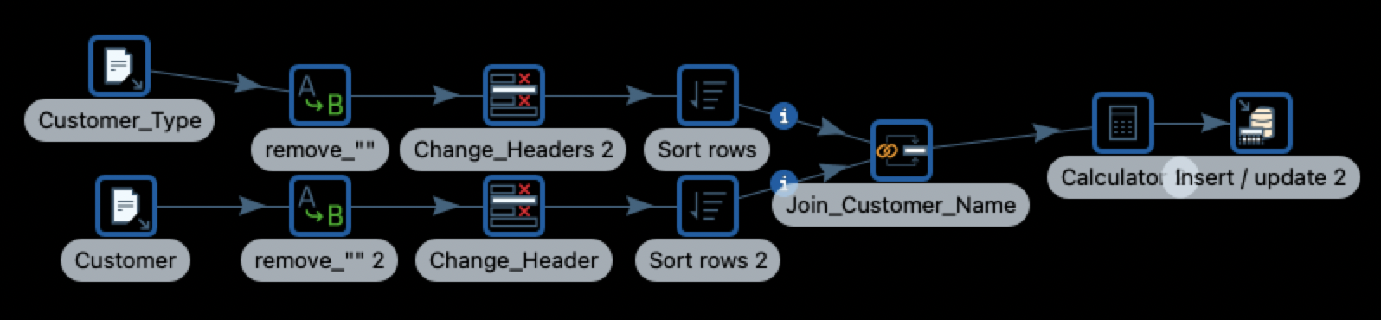**TPCW Customer**

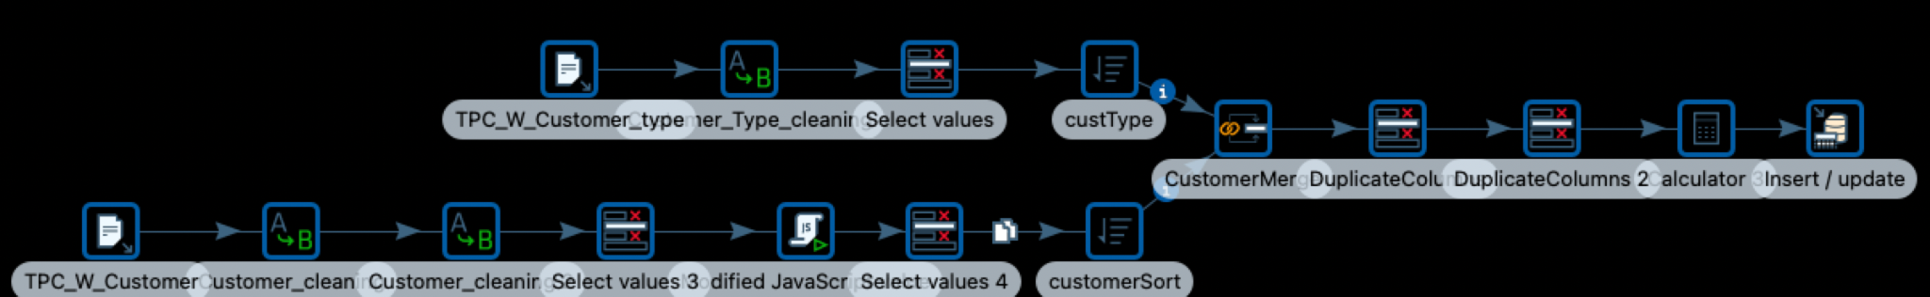

**PEC Customer**

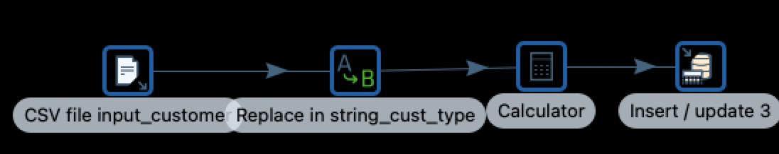

**Merging TPCE, TPCW, and PEC into Customer table**

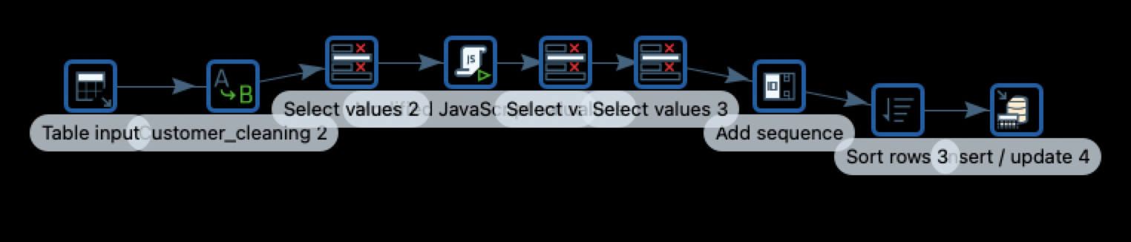

**TPCE Product**

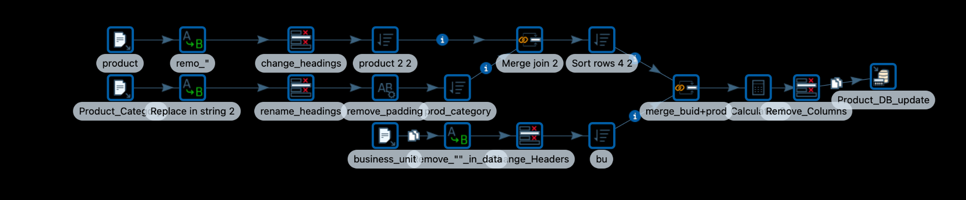

**TPCW Product**

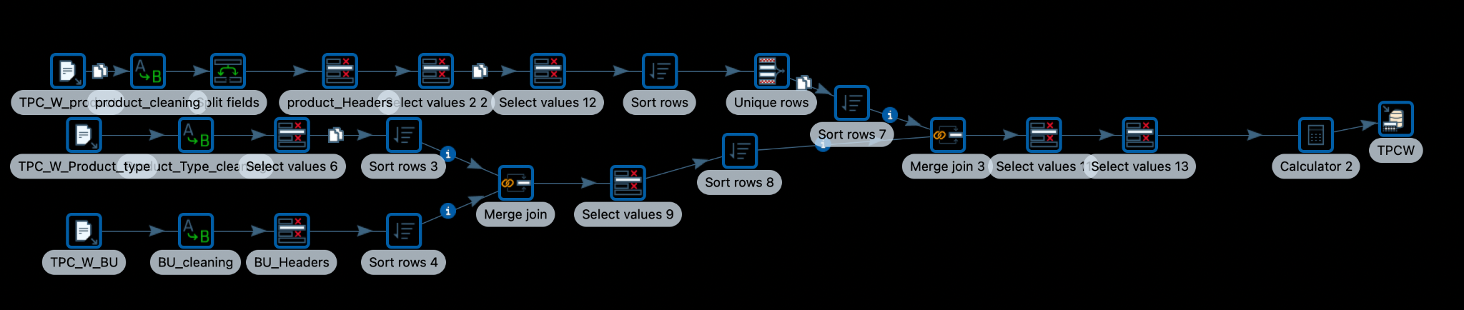

**PEC Product**

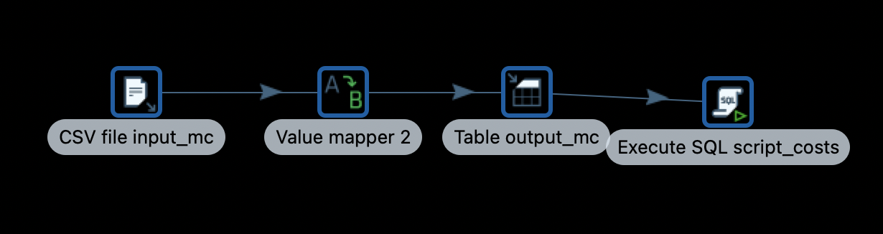

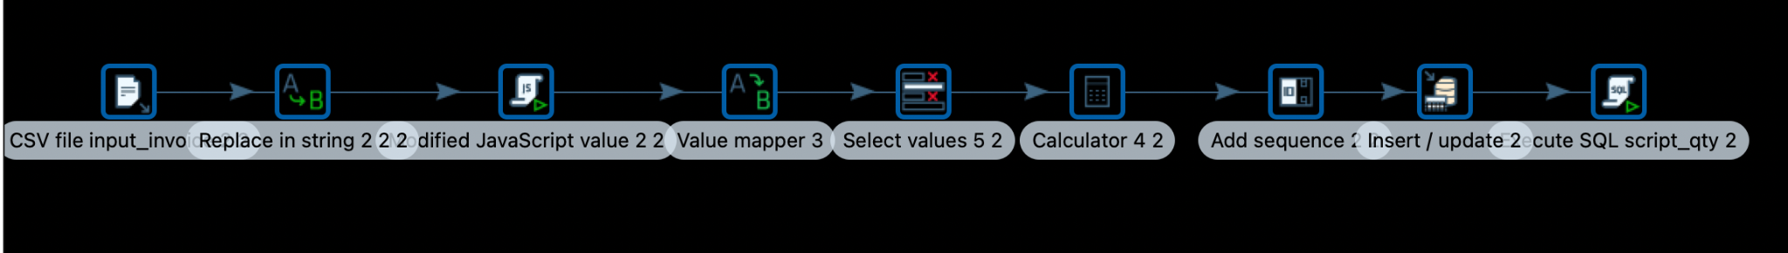

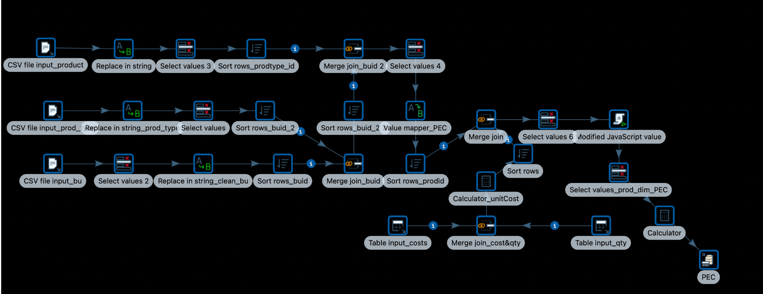

**Merging TPCE, TPCW, and PEC into Product**

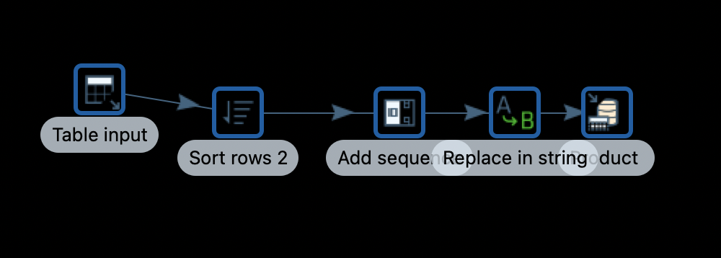

**TPCE Supplier**

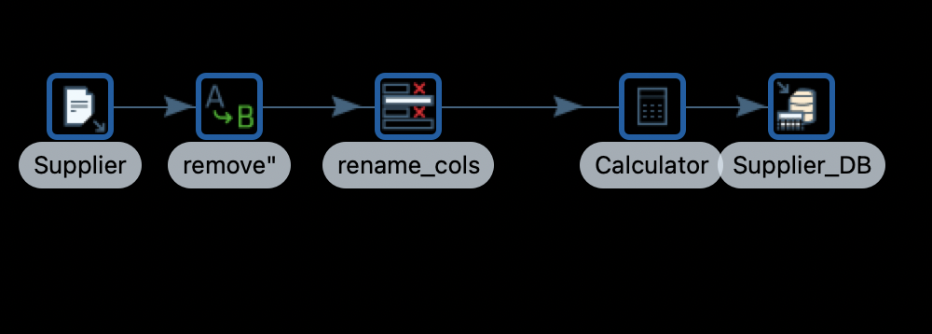

**TPCW Supplier**

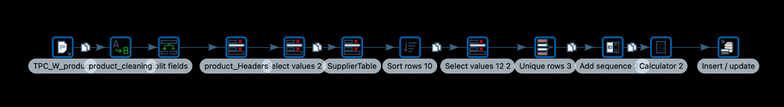

**PEC Supplier**



**Merging TPCE, TPCW, and PEC into Supplier**

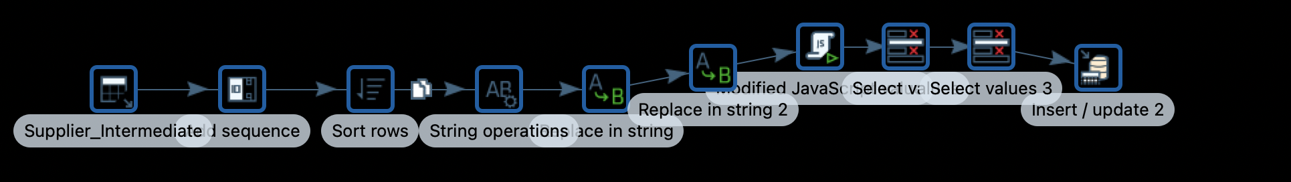

**TPCE Sales Date**

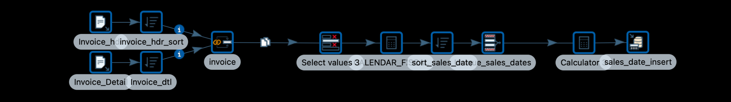

**TPCW Sales Date**

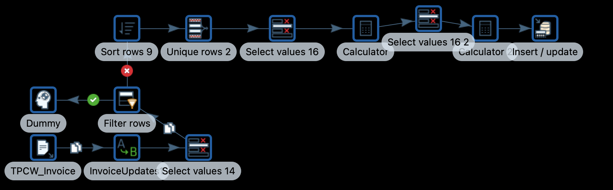

**PEC Sales Date**

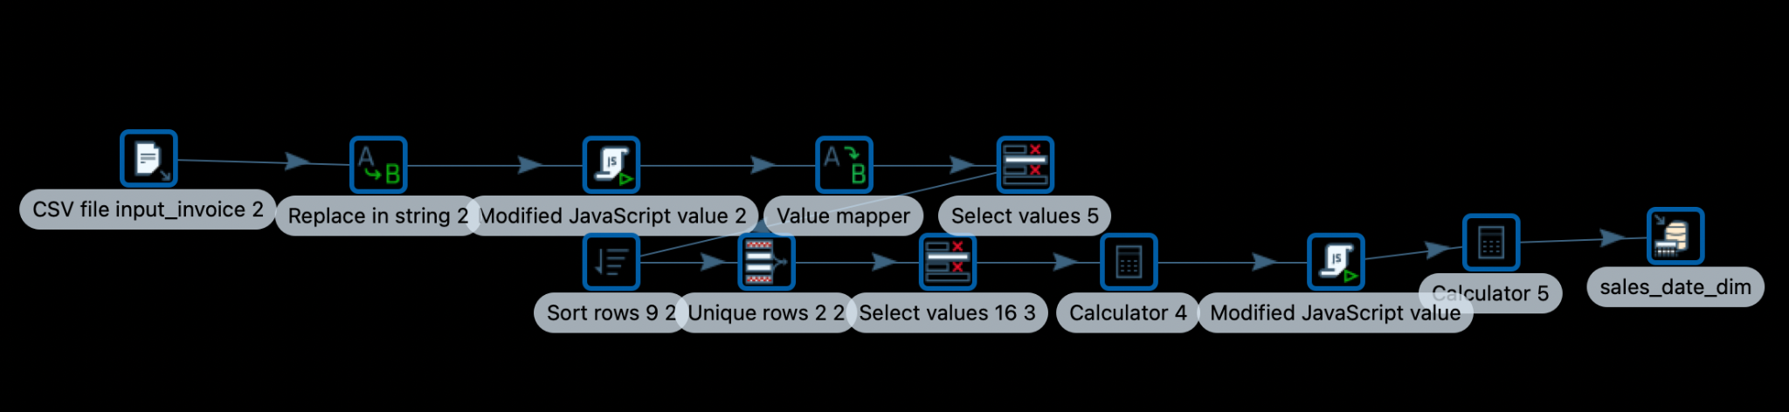

**Merging TPCE, TPCW, and PEC into Sales Date**

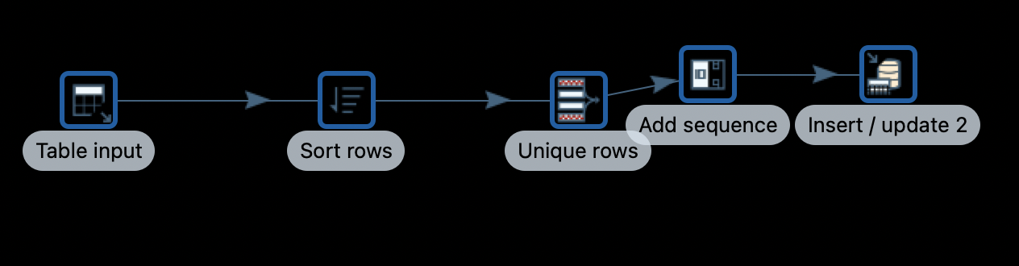

**PEC Order Date**

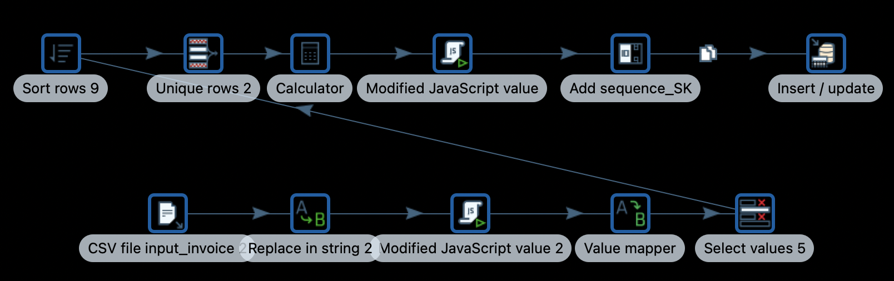

**PEC Junk Dimension**

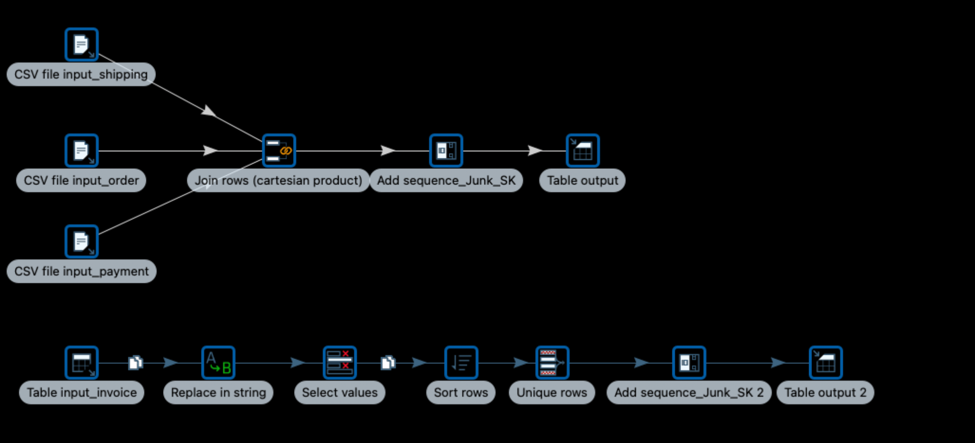

**TPCE Fact Table**

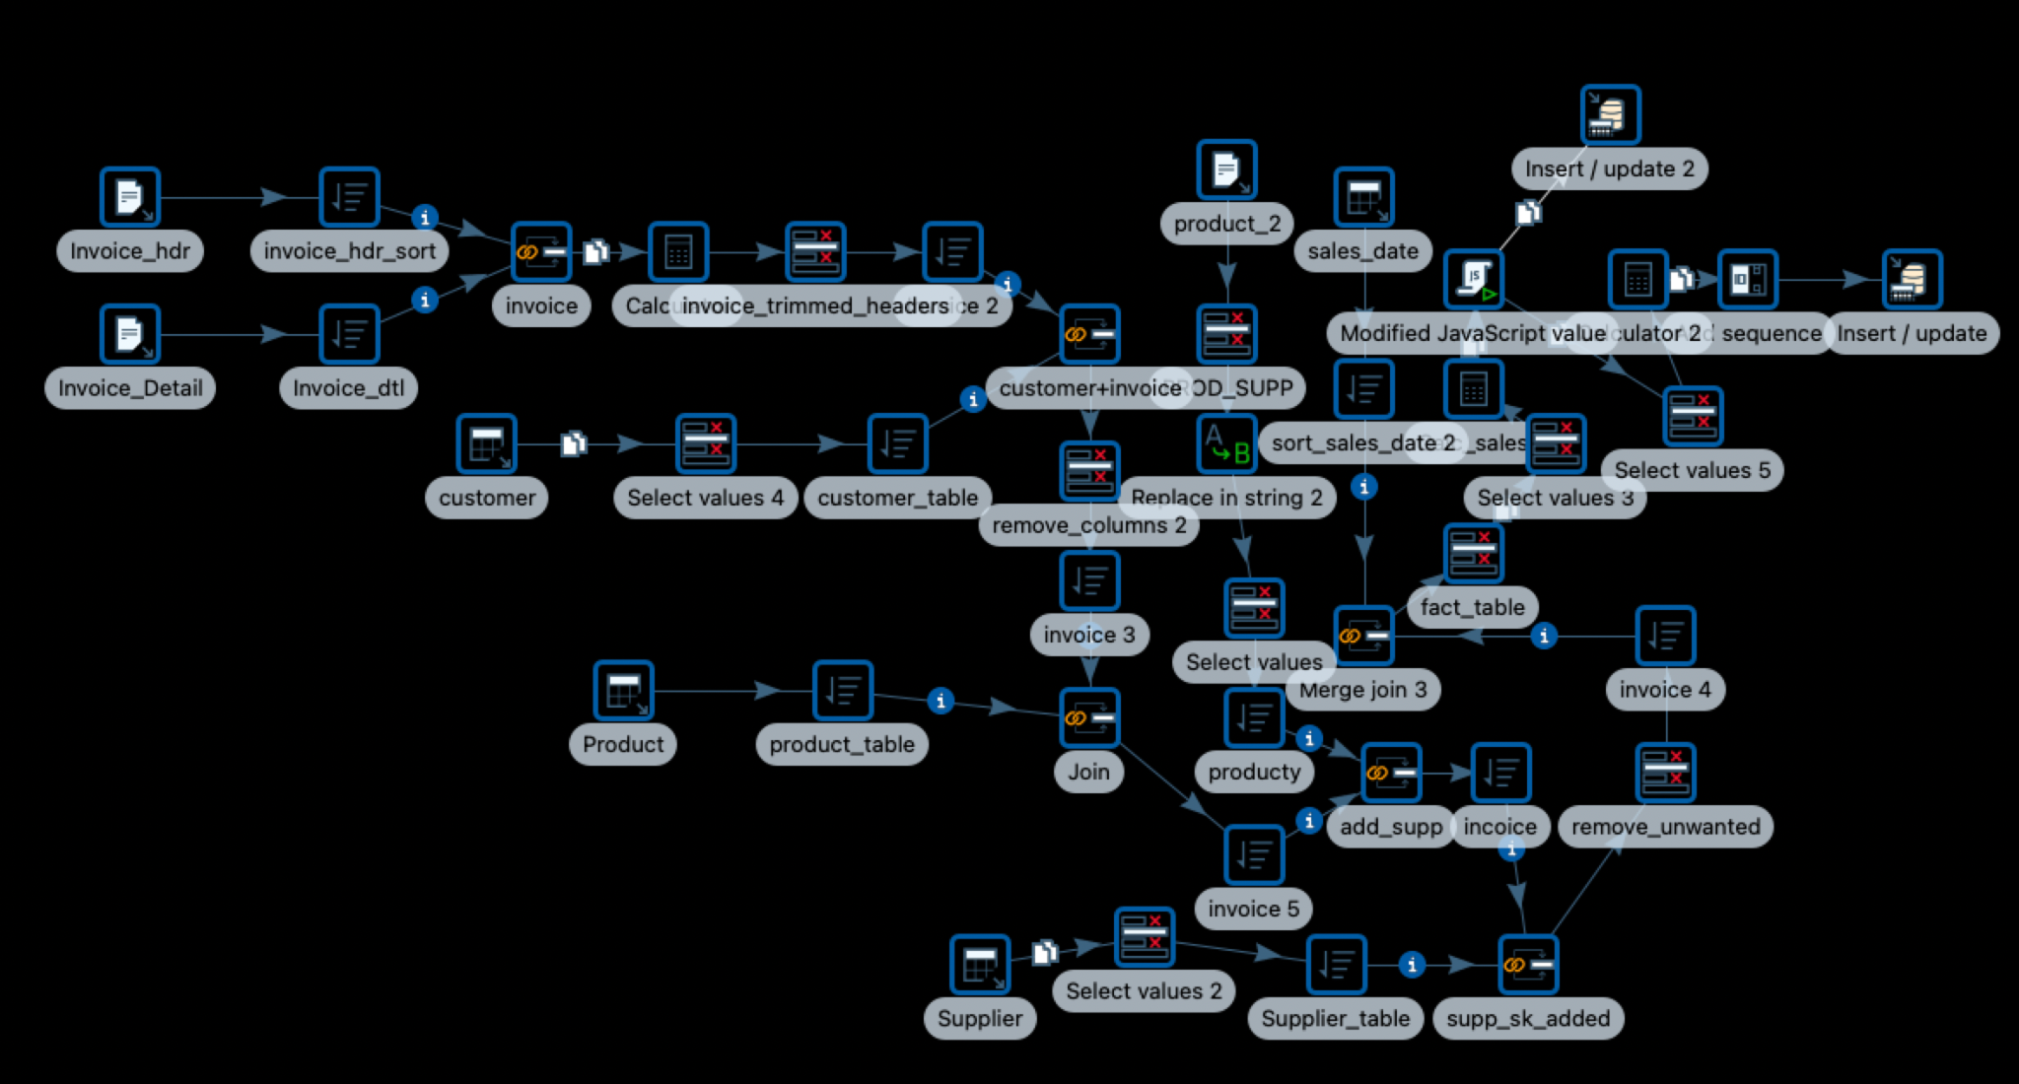

**TPCW Fact Table**

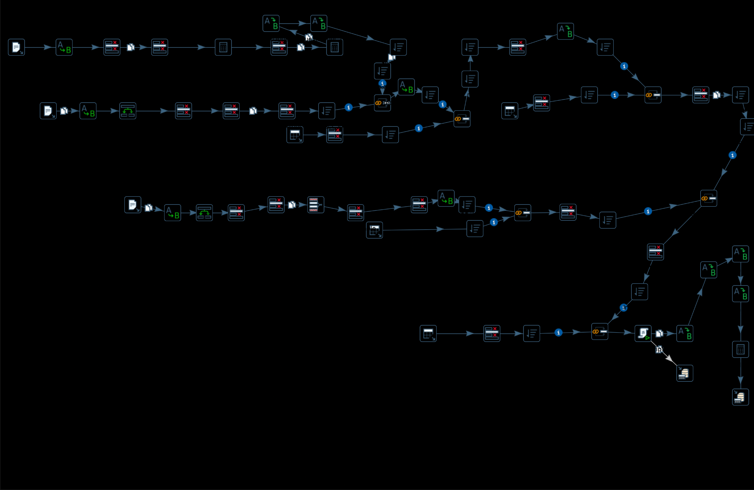

**PEC Fact Table**

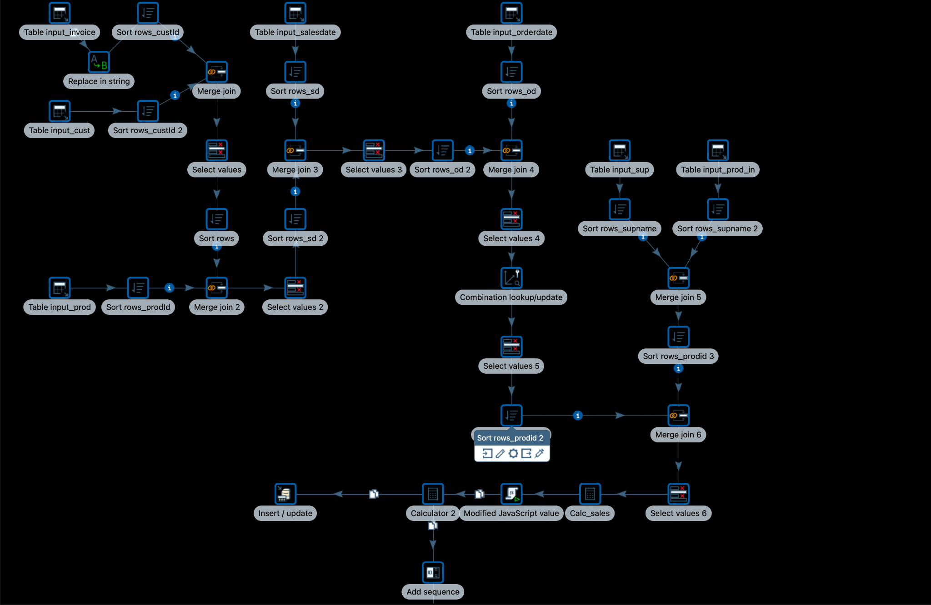

## 3. Table Population

|  |  |
| --- | --- |
| DM Table | Table Population Process (attach code) |
| Customer, Product,Supplier, Sales Date, Dimension’s | The CSV files were cleaned individually from TPCE, TPCW, and PEC and inserted individually into the respective Intermediate tables. Then all rows from the intermediate table were taken, SKs were added and inserted into their corresponding dimension tables.  Example: TPCE Customer CSV was cleaned and pushed into the intermediate file. Similarly TPCW, and PEC Customer CSVs were cleaned and pushed into the intermediate file. Then from the Customer intermediate file we add a sequence in pentaho to add the SK and we push all the rows with SK into the Customer Dimension table. |
| Options Junk Table | All possible required combinations between Transportation method, payment method, and Ordering method are created in Pentaho. Only those records that are used are kept and the remaining are deleted using Pentaho. |
| Order Date Dimension | All possible unique data values from the PEC are found and inserted into the Order_Date dimension table after adding the SKs using the add sequence in pentaho. |
| Fact Table | Individual companies (TPCE, TPCW, PEC) invoice files are cleaned and merged with the existing Dimension Tables and inserted into the Fact table using Pentaho. |

Customer Dimension Table

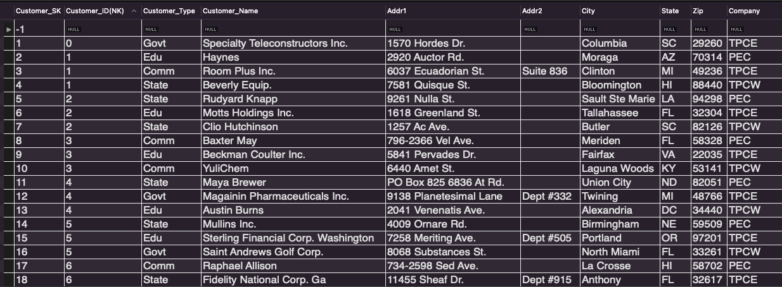

Product Dimension Table

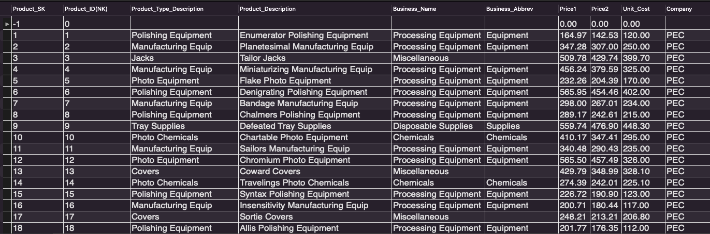

Supplier Dimension Table

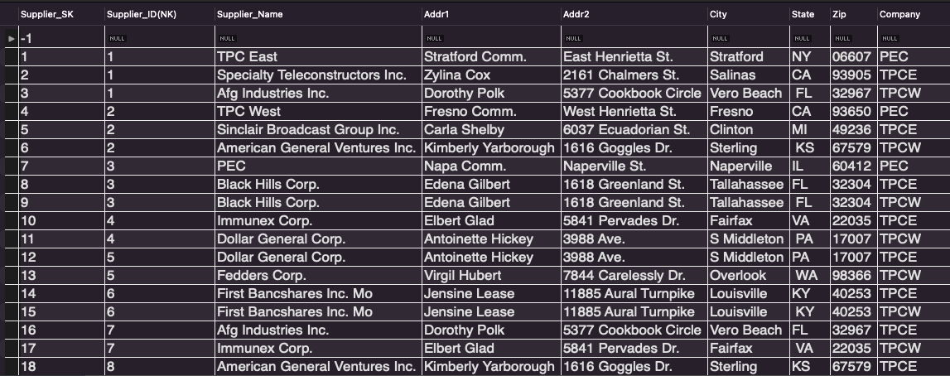

Options Junk Table

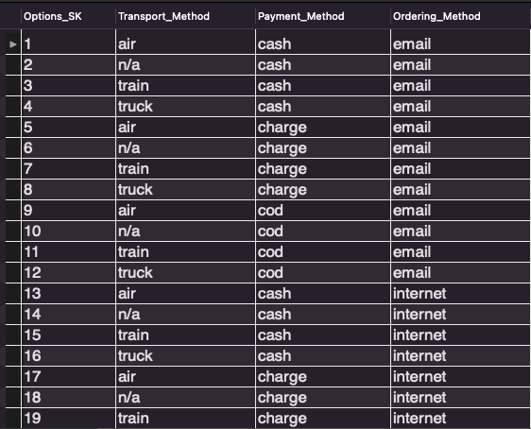

Sales Date Dimension Table

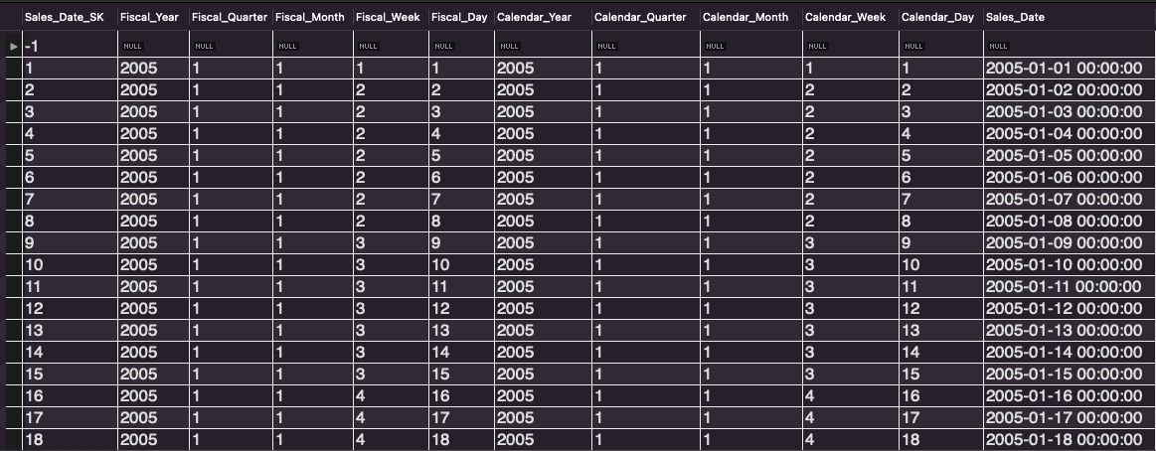

Order Date Dimension Table

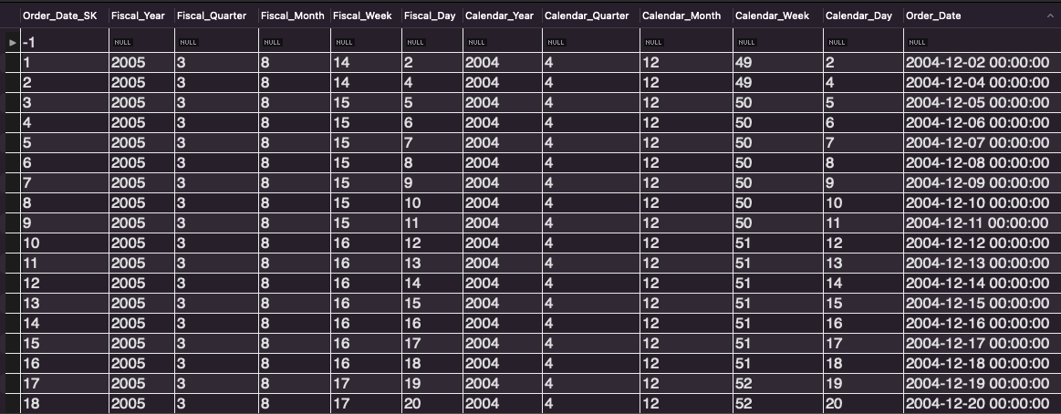

Fact Table

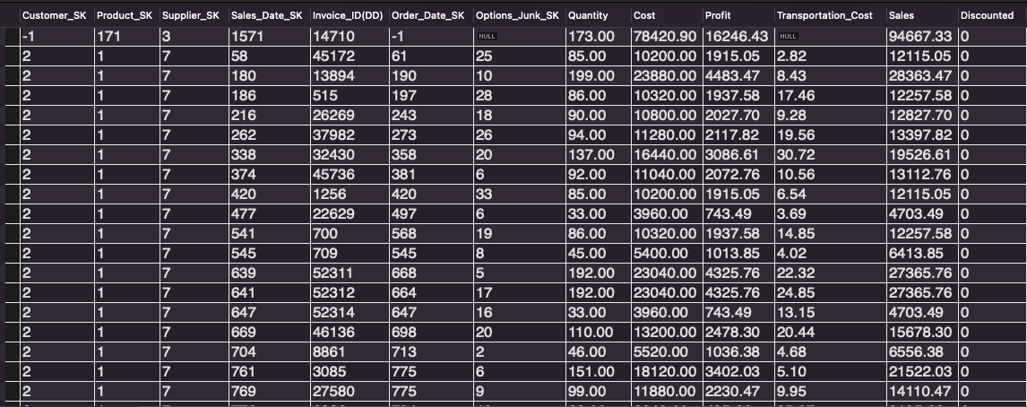

# VII. End-User Applications

## 1. Queries

|  |
| --- |
| User Question/Reporting Need |
| Total cost of products for each supplier per product. |
| SQL Code |
| use `DW-2211-Team2_SalesOrders`;  Select sum(F.Cost + F.Transportation_Cost) as Total_Cost, count(F.Product_SK) as Quantity_purchased, PD.Product_Description, SD.Supplier_Name  from Financial_Analysis_Fact F  Join Supplier_Dim SD Join Product_Dim PD  where F.Supplier_SK = SD.Supplier_SK  and F.Product_SK = PD.Product_SK  Group By F.Supplier_SK, F.product_sk  Order By Total_Cost desc; |
| Supporting Index(es) |
| Supplier, Product, Fact Table |
| Output |
|  |

|  |
| --- |
| User Question/Reporting Need |
| Reports should be able to report sales, costs and gross profit (sales minus costs) per month per year. This query finds the Total Sales, Total cost, and Total Profit on a monthly basis. |
| SQL Code |
| use `DW-2211-Team2_SalesOrders`;  Select sum(F.Sales) as Total_Sales, sum(F.Cost + F.Transportation_Cost) as Total_Costs, sum(F.Profit) as Total_Profits,  Sdt.Calendar_Month, Sdt.Calendar_Year  from Financial_Analysis_Fact F  Join Sales_Date_Dim SDt  where F.Sales_Date_SK = SDt.Sales_Date_SK  Group By Calendar_Year, Calendar_Month  Order By Calendar_Year, Calendar_Month; |
| Supporting Index(es) |
| Sales Date, Fact Table |
| Output |
|  |

|  |
| --- |
| User Question/Reporting Need |
| The percentage of invoices that are COD. |
| SQL Code |
| use `DW-2211-Team2_SalesOrders`;  Select CNT_COD.c * 100 / Total_All.t as COD_Percentage FROM  (Select count(*) as c from (SELECT count(*) from Financial_Analysis_Fact F  JOIN Options_Junk OJ on F.Options_Junk_SK = OJ.Options_SK  WHERE Payment_Method = 'COD'  GROUP BY `Invoice_ID(DD)`) AS Only_COD ) AS CNT_COD  CROSS JOIN  ( Select count(*) as t from (SELECT count(*) from Financial_Analysis_Fact F  JOIN Options_Junk OJ on F.Options_Junk_SK = OJ.Options_SK  WHERE Options_SK is not null and  Payment_Method in ('COD', 'charge', 'cash')  GROUP BY `Invoice_ID(DD)`) AS All_Payments_Methods ) AS Total_All; |
| Supporting Index(es) |
| Fact Table, Junk dimension |
| Output |
|  |

## 2. A View

Create a view that displays the Top Sellers that have contributed in earning the maximum profit for the company:

*CREATE OR REPLACE VIEW BEST_SELLERS AS*

*SELECT ft.Supplier_SK, sd.Supplier_Name, sd.Addr1, sd.Addr2, sd.City, sd.State, sd.Zip,*

*sum(ft.Sales) as Total_Sales_Amount, sum(ft.Profit) as Total_Profit, sum(ft.Cost) as Total_Cost*

*FROM Financial_Analysis_Lost.Supplier_Dim sd*

*JOIN Financial_Analysis_Lost.Financial_Analysis_Fact ft ON sd.Supplier_SK = ft.Supplier_SK*

*WHERE ft.SUPPLIER_SK != -1*

*GROUP BY ft.Supplier_SK*

*ORDER BY Total_Profit DESC;*

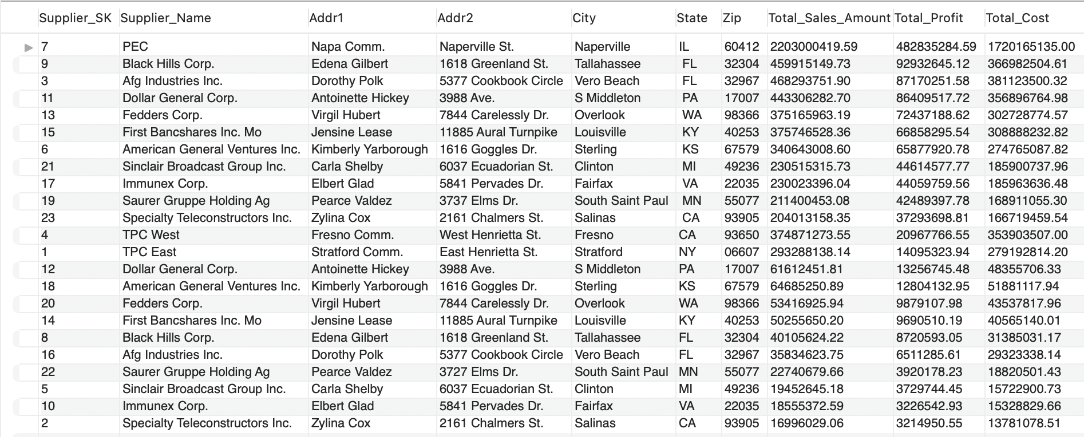

## 3. Aggregated Data Marts

3 Aggregated Data Marts have been implemented. The implemented Aggregated Data Marts are:

1. Lost Aggregated Data Mart

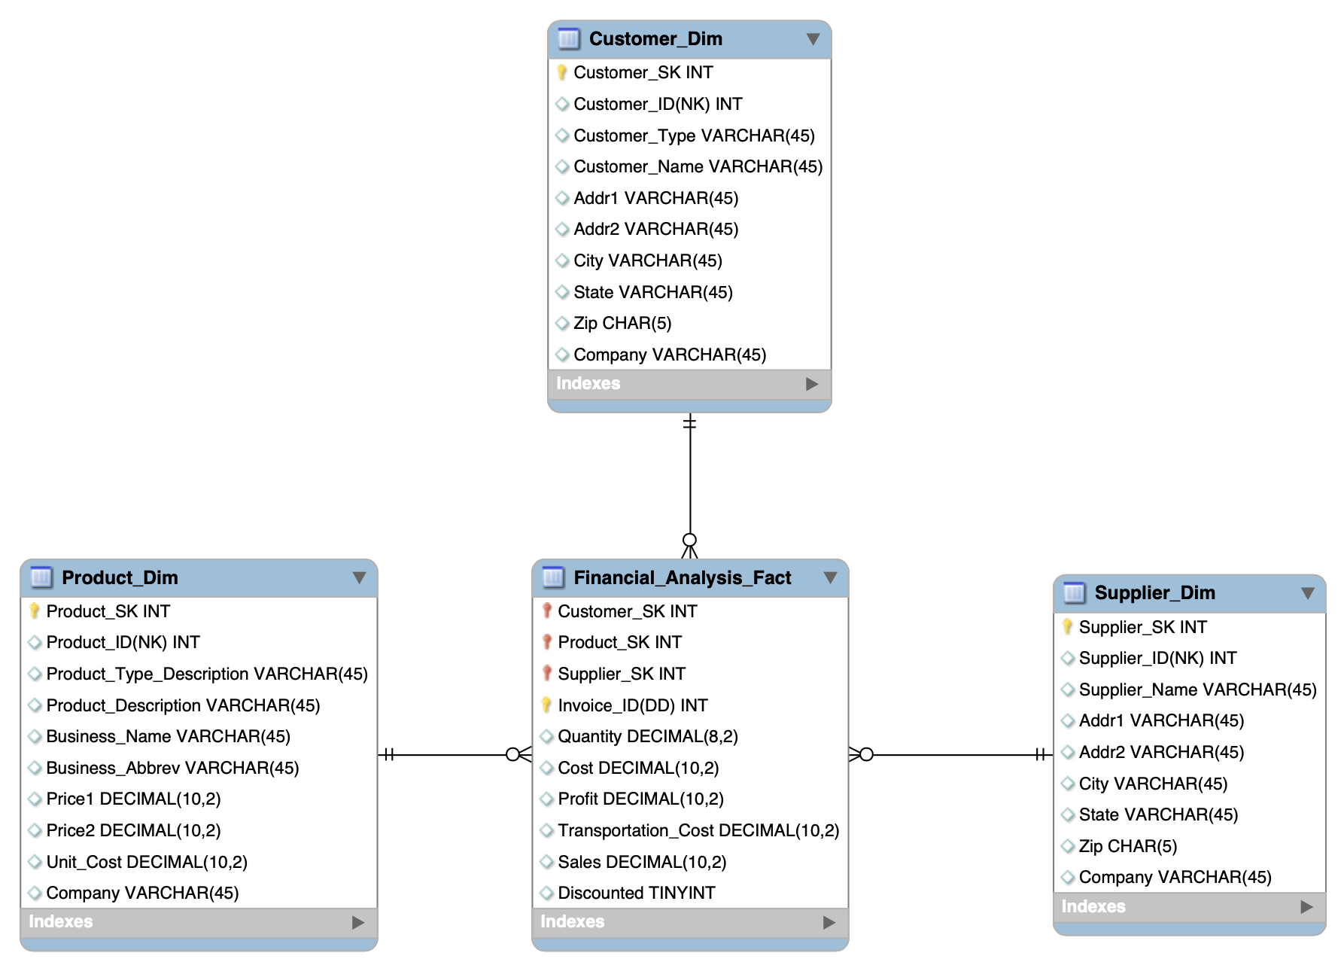

# Fig.: Lost Aggregated ERD

Use Cases:

1. List of Customers buying a particular product type.
2. Number of products sold by each supplier
3. Number of Customers brought in by each supplier.
4. Most Selling Product
5. Most Profit (Profit i.e. Profit = Sales - Cost) generating Supplier

SQL Queries:

1. List of Customers buying a particular product type ‘Polishing Equipment’:  
   *SELECT ft.Customer_SK, cd.`Customer_ID(NK)`, cd.Customer_Name, cd.Addr1, cd.Addr2, cd.City, cd.State, cd.Zip, pd.Product_Type_Description, sum(ft.Sales) as Total_Sales_Amount,*

*sum(ft.Profit) as Total_Profit, sum(ft.Quantity) as Total_Qty_Purchased*

*FROM Financial_Analysis_Lost.Product_Dim pd*

*JOIN Financial_Analysis_Lost.Financial_Analysis_Fact ft ON pd.Product_SK = ft.Product_SK*

*JOIN Financial_Analysis_Lost.Customer_Dim cd ON cd.Customer_SK = ft.Customer_SK*

*WHERE pd.Product_Type_Description = 'Polishing Equipment'*

*GROUP BY ft.Customer_SK;*  
Output:  
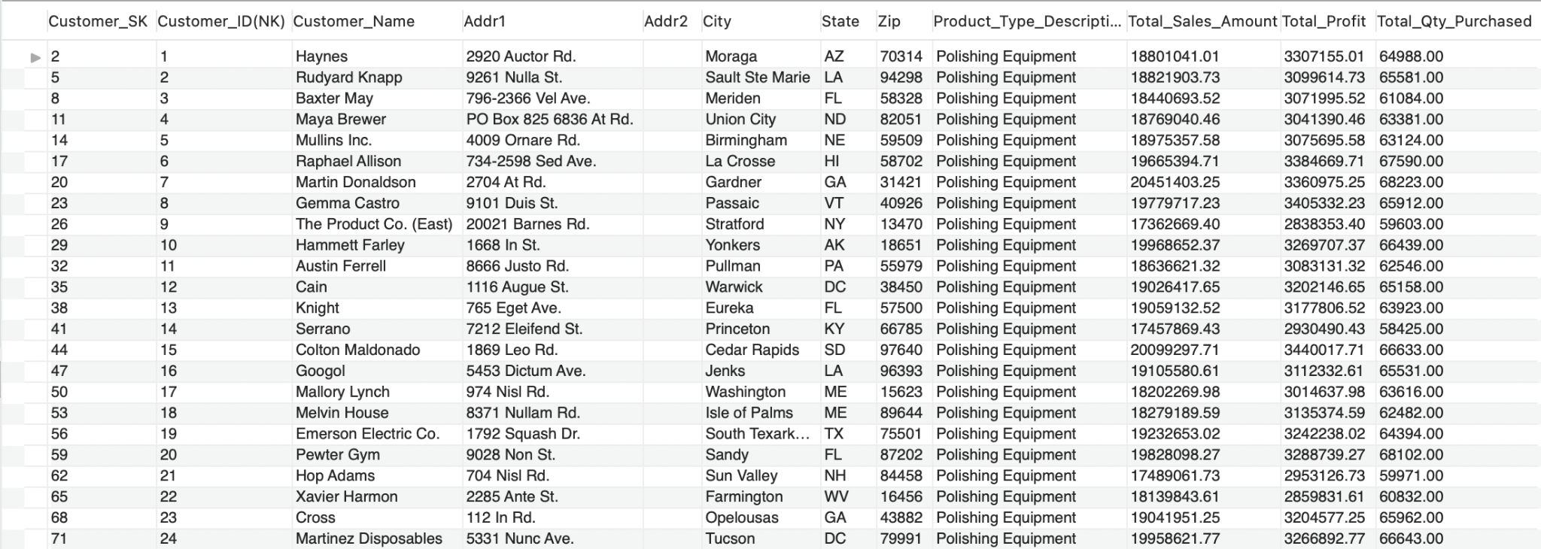

1. Most Profit (Profit i.e. Profit = Sales - Cost) generating Supplier:

*SELECT ft.Supplier_SK, sd.`Supplier_ID(NK)`, sd.Supplier_Name, sd.Addr1,*

*sd.Addr2, sd.City, sd.State, sd.Zip, sum(ft.Sales) as Total_Sales_Amount,*

*sum(ft.Profit) as Total_Profit, sum(ft.Cost) as Total_Cost*

*FROM Financial_Analysis_Lost.Supplier_Dim sd*

*JOIN Financial_Analysis_Lost.Financial_Analysis_Fact ft*

*ON sd.Supplier_SK = ft.Supplier_SK*

*GROUP BY ft.Supplier_SK ORDER BY Total_Profit DESC LIMIT 1;*

Output:  


b) Collapsed Data Mart

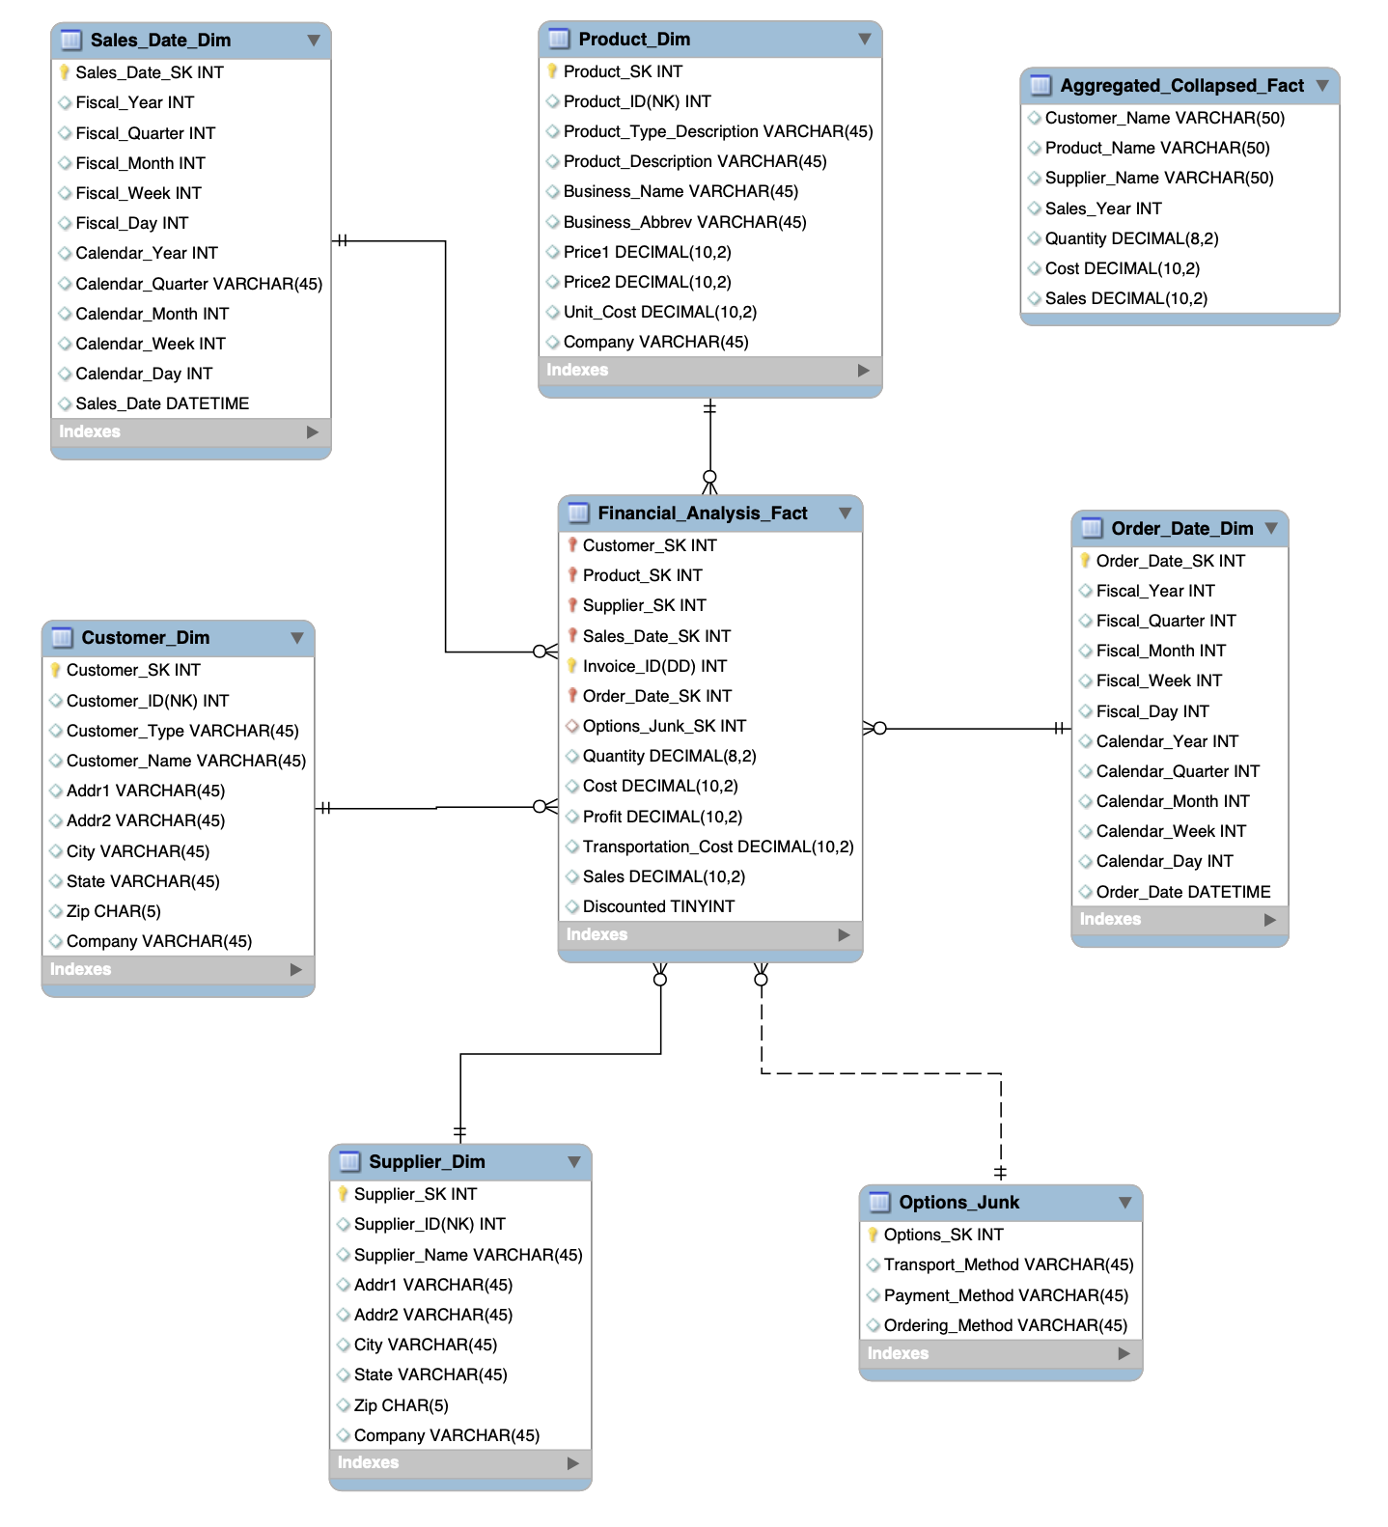

Fig.: Collapsed Aggregated ERD

Use Case:

1. Quantity of Products sold yearly
2. Number of Customers each year
3. Yearly Top Customer (Customer who has given maximum revenue(Sales))
4. Yearly Top Product (Product that has generated highest revenue(Sales))
5. Average Sales/Cost/Quantity of a particular product/products bought from a particular supplier

SQL Queries:  
a) Quantity of Products sold yearly:  
  
*SELECT sum(Quantity) as Total_Qty_Sold, sales_year*

*FROM Financial_Analysis_Collapsed.Aggregated_Collapsed_Fact ft*

*where sales_year is not null*

*group by sales_year;*  
  
Output:

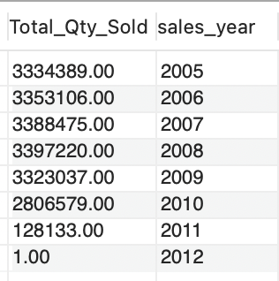

b) Number of Customers each year:  
  
*SELECT COUNT(*) as No_Of_Customers, Sales_year*

*FROM Financial_Analysis_Collapsed.Aggregated_Collapsed_Fact ft*

*WHERE Sales_year is not null*

*GROUP BY Sales_year;*

Output:  
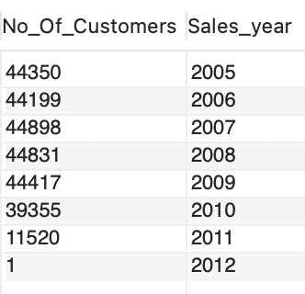

c) Shrunken Data Mart

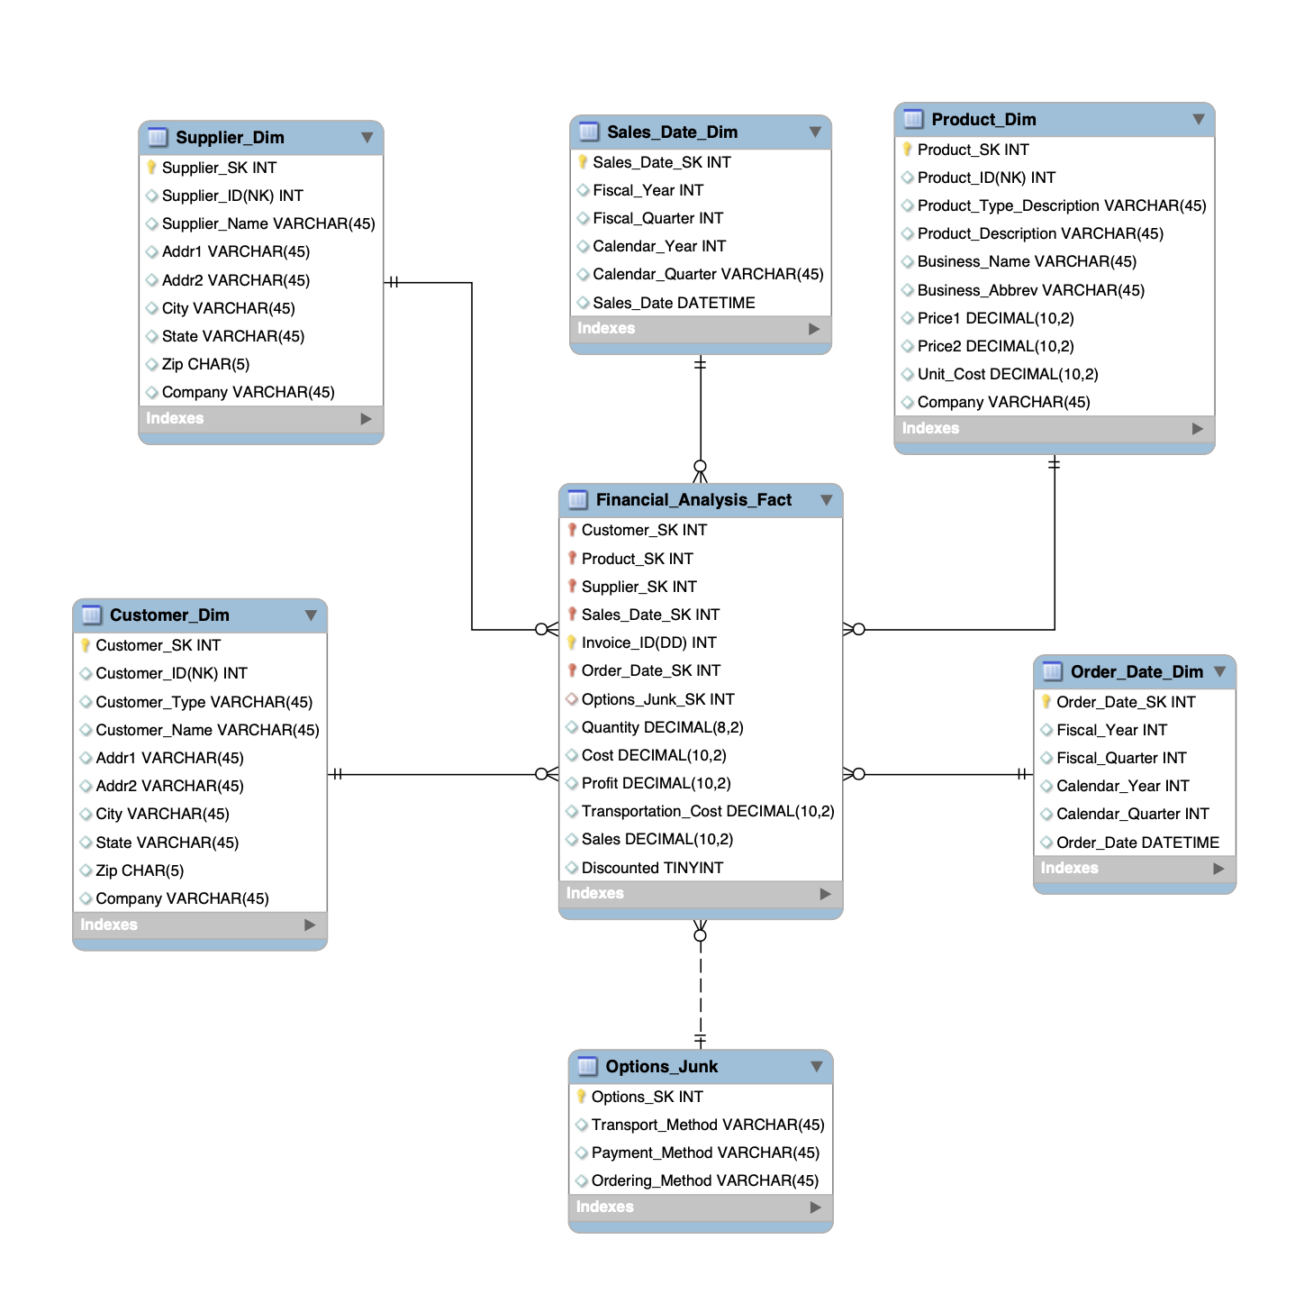

Fig.: Shrunken Aggregated ERD

Use Cases:

Average Quarterly Sales

1. Average Number of Customers per Quarter
2. Quarterly Profit

SQL Queries:

a) Average Quarterly Sales:  
*SELECT AVG(Sales) as Avg_Sales, sd.Calendar_Quarter, sd.Calendar_Year*

*FROM Financial_Analysis_Shrunken.Financial_Analysis_Fact ft*

*JOIN Sales_Date_Dim sd on ft.Sales_Date_SK = sd.Sales_Date_SK*

*WHERE sd.Calendar_Quarter is not null*

*GROUP BY sd.Calendar_Quarter, sd.Calendar_Year*

*order by sd.Calendar_Year, sd.Calendar_Quarter;*

Output:

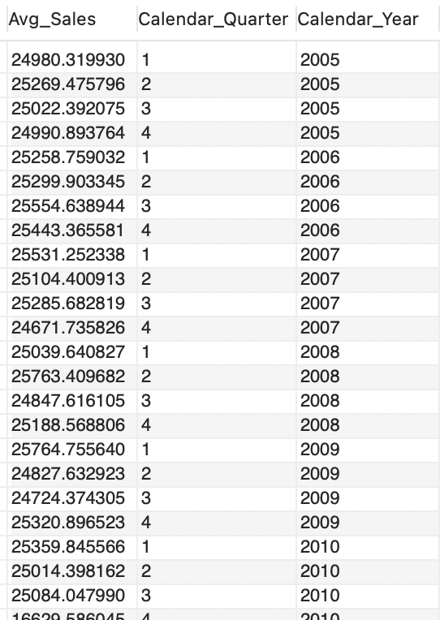

b) Average Number of Customers per Quarter

*SELECT SUM(Profit) as Quarterly_Profit, sd.Calendar_Quarter, sd.Calendar_Year*

*FROM Financial_Analysis_Shrunken.Financial_Analysis_Fact ft*

*JOIN Sales_Date_Dim sd on ft.Sales_Date_SK = sd.Sales_Date_SK*

*WHERE sd.Calendar_Quarter is not null*

*GROUP BY sd.Calendar_Quarter, sd.Calendar_Year*

*ORDER BY sd.Calendar_Year, sd.Calendar_Quarter;*

Output:

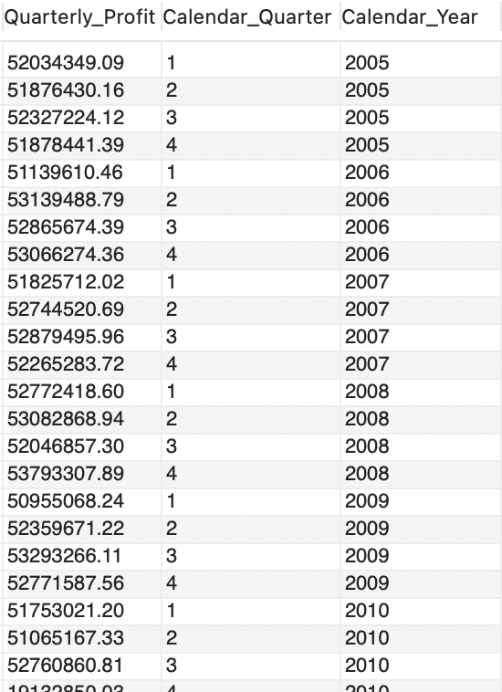

# VIII. Handling Slowly Changing Dimensions (SCD)

Source Data for SCD type 1 and SCD Type 2:

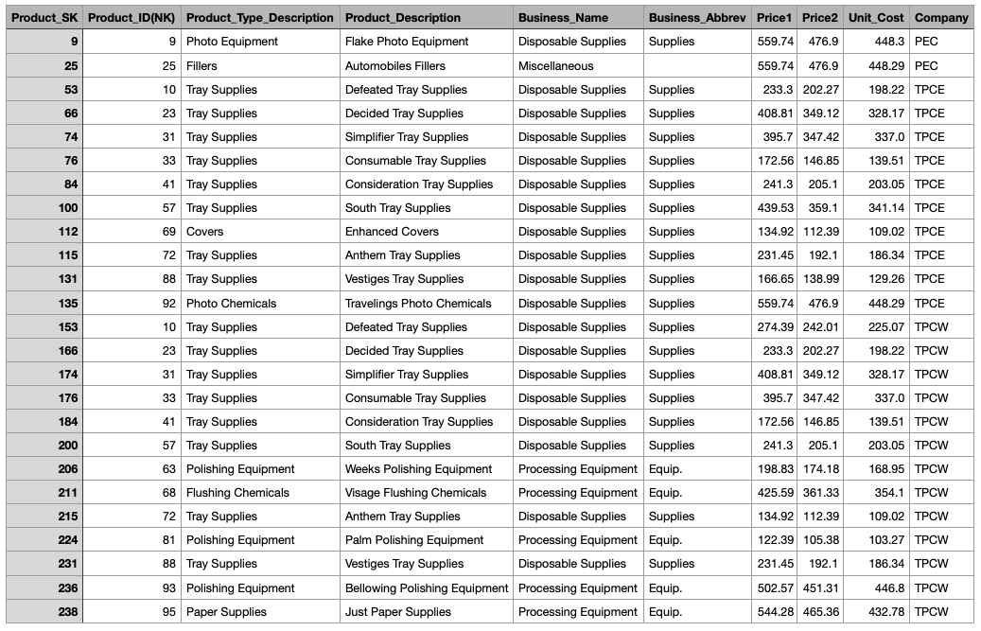

SCD Type 1:

Changes have occured to the rows with SKs = 9, 112, 135, 211, 238

Before SCD Type 1:

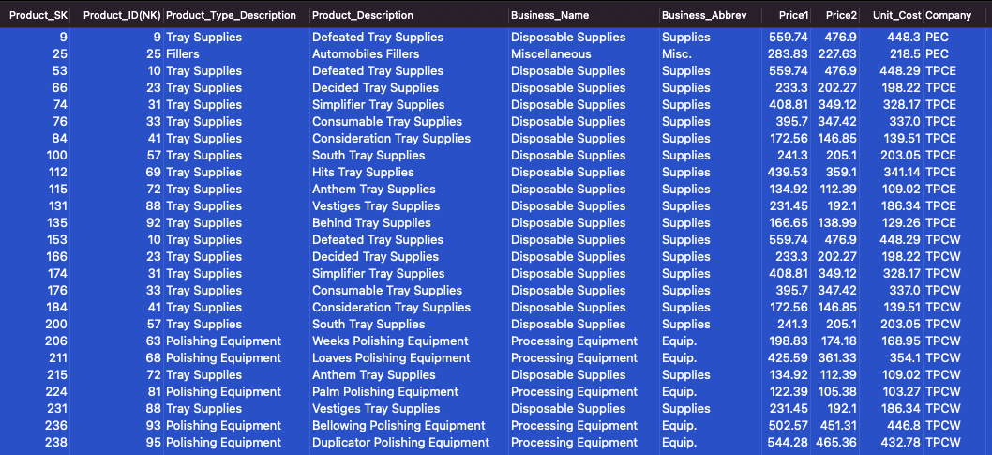

After SCD Type 1:

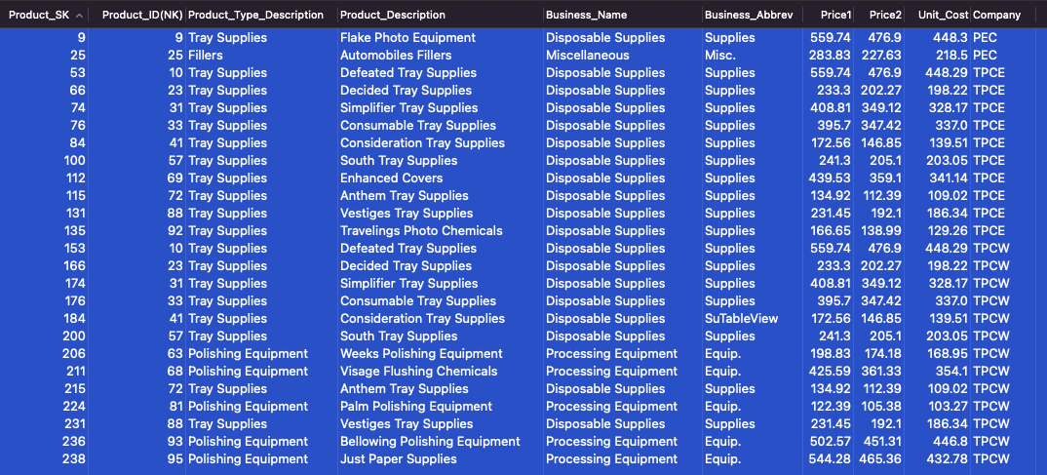

SCD Type 1 Attributes: Product Description

Steps Involved:

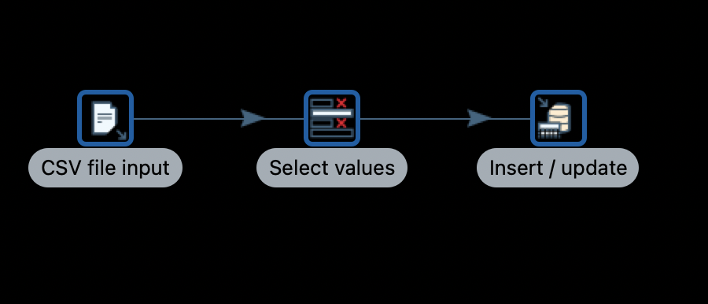

1. We simply read all the values from the Source file and update only the Product_Description of the Database. Product_Descriptions that do not need to be changed are also updated but with the same description and hence it remains unchanged effectively.

SCD Type 6:

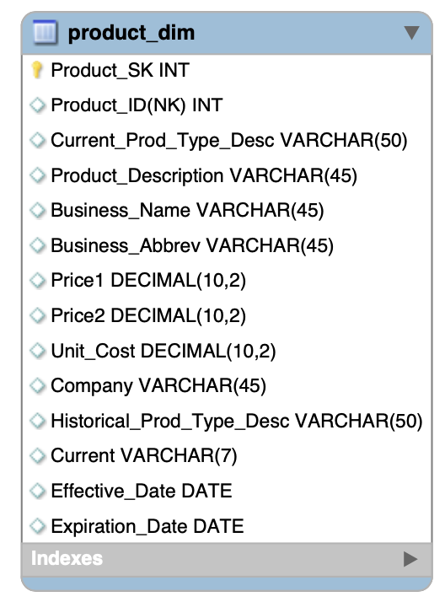

Fig.: SCD Type 6 ERD

SCD type 6 Attribute: Product Type Description

Before (Only Affected rows are displayed for convenience):

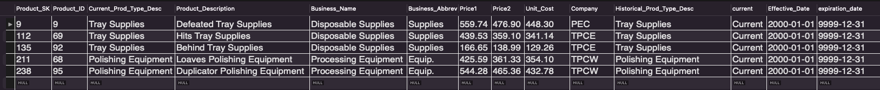

After (Only Affected rows are displayed for convenience):

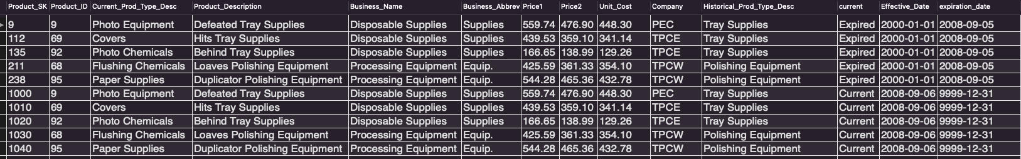

Steps Involved:

1)

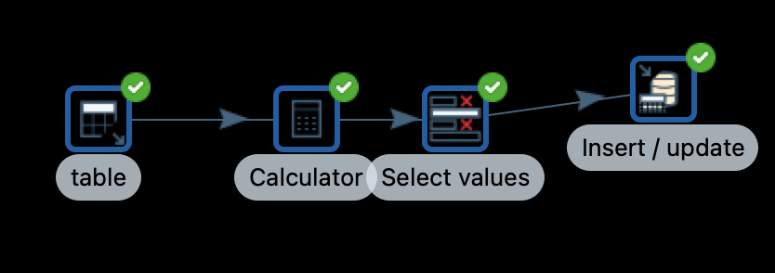

Update Historical_Prod_Type_Desc with the Current_Prod_Type_Desc since initially all unchanged rows have the same Historical_Prod_Type_Desc and Current_Prod_Type_Desc.

Set all Current flag values to “Current”.

Set Effective date to 1st Jan 2000.

Set Expiry date to 31st December 9999.

2)

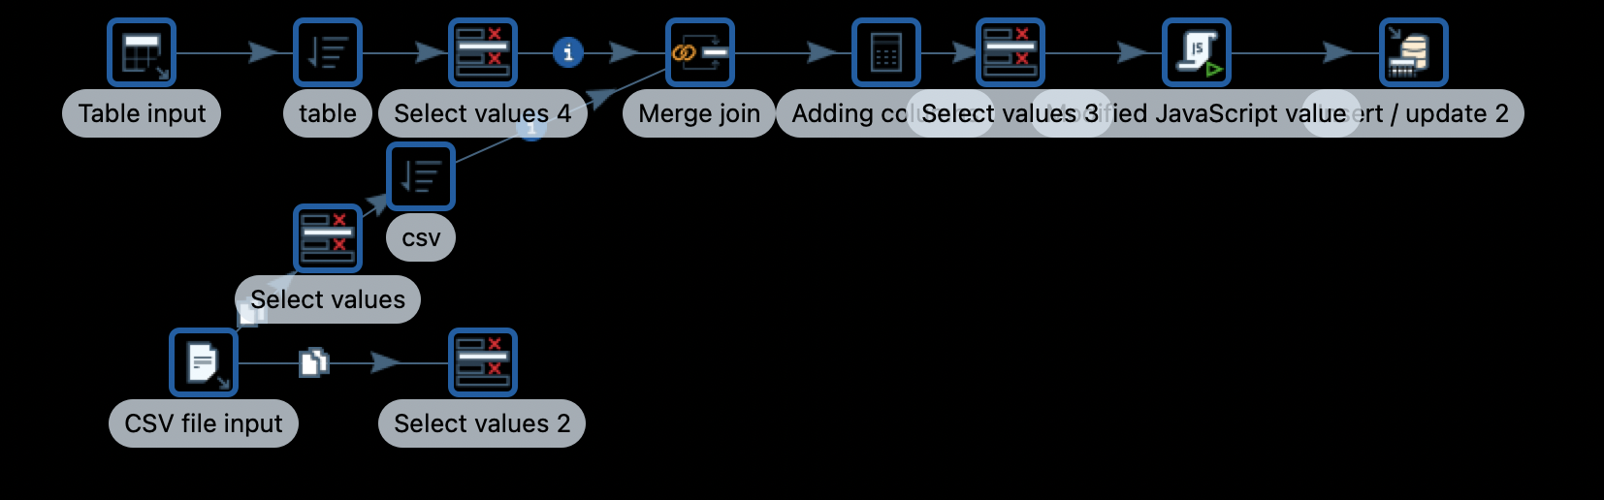

Detects the SK’s of which Product Type Description has changed.

Update the current to “Expired”.

Change the Expiration date to a day before the day of the change.

Add new rows with new SKs.

The new rows should have the initial Type Name in Historical Product Type Description.

The new rows should have the updated Type Name in the Current Product Type Description.

The new rows will have their Current flag set to “Current”.

An intermediary field called flag is used to detect those rows that need to be updated.

Flag = 1 -> requires update.

Flag = 0 -> does not require an update.

3)The Intermediary field flag should be dropped.

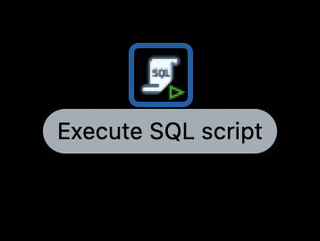

# IX. Many-to-Many (N-M) Relationship Implementation Option

A *many-to-many relationship* occurs when multiple records in a table are associated with multiple records in another table. For example: a many-to-many relationship exists between customers and products: customers can purchase various products, and products can be purchased by many customers.

The following are some of the possible implementations:

Implementation 1:

We have a Fact Table which contains both the attributes of the Separate relationship tables. These Separate relationships tables can relate to each other in N-M relationships. in another look up table.

For example: if we have to find the relationship between product and customer. We store the customer SK and Product SK in the Fact table. Then we can lookup using the lookup table. The look up table has both product sk and customer sk. Here the Fact table will not store the reference to the lookup table.

Implementation 2:

We can convert the N-M relationship into a compound attribute relationship where one attribute is treated as a child of the other and have a compound key for the lower level attribute.

In our scenario we can recreate this by having the Customer Sk and Product SK in the Fact table and having either the customer SK in the product or the Product SK in the customer table.

Implementation 3:

This is the implementation that we used in our scenario. This is the most versatile way to create a N-M relationship.

We create a lookup table that has the attributes of both the tables. Then the Fact table will be linked only to the lookup table and not both the tables.

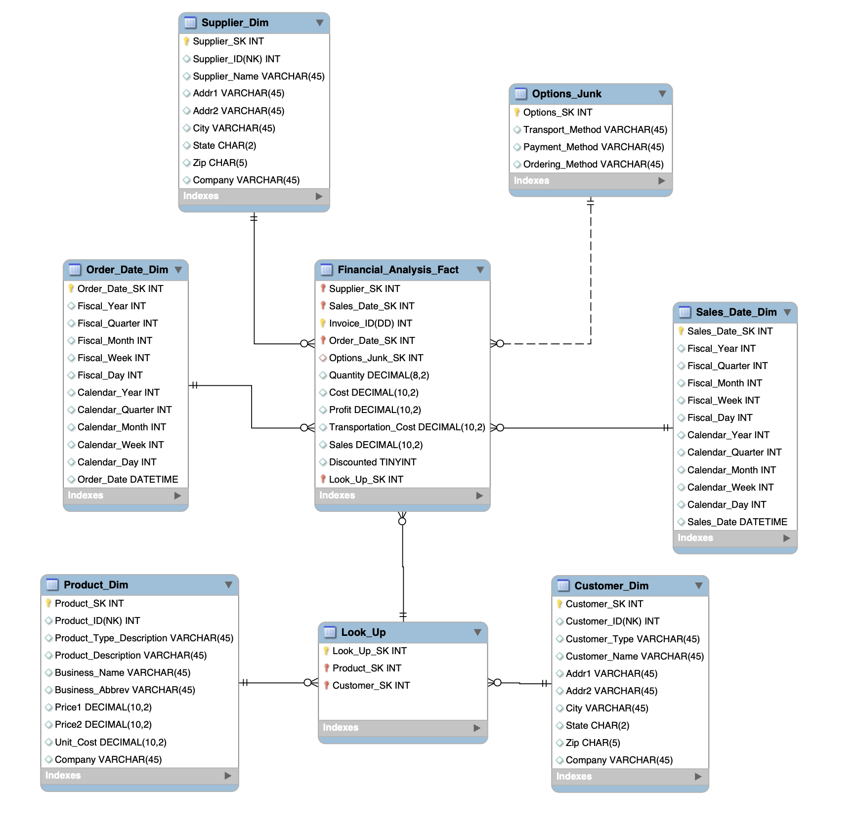

References:

1. <https://en.wikipedia.org/wiki/Many-to-many_(data_model)>
2. <https://fmhelp.filemaker.com/help/18/fmp/en/index.html#page/FMP_Help/many-to-many-relationships.html>
3. <https://dzone.com/articles/how-to-handle-a-many-to-many-relationship-in-datab>
4. <https://opentextbc.ca/dbdesign01/chapter/chapter-8-entity-relationship-model/>
5. <https://support.airtable.com/hc/en-us/articles/218734758-Airtable-s-guide-to-many-to-many-relationships>
6. https://doc-archives.microstrategy.com/producthelp/10.4/ProjectDesignGuide/WebHelp/Lang_1033/Content/ProjectDesign/Supporting_many_to_many_and_joint_child_relationsh.html

X. Appendix (Fix Lab #3 Problems)

The Customer table that contained the records from all the divisions was made to have uniformity. The commas and periods were removed. Customer type was made to have a uniform value i.e State vs State_Local gov, Edu. vs Education.

All the states in the customer table were made to be in char(2) i.e state abbreviation.

All the states in the Supplier table were made to be in char(2) i.e state abbreviation.

Null records (Dummy) were added to all the tables, except the fact and junk table.

The Zip code in the Supplier and Customer table were made from int to char(5). Those zip values that had only 4 digits are padded with a 0 on the left side and converted to char(5).

Uniformity amongst the addresses of customers in the Customer table. Some places had corporation vs corp, company vs co., Street vs st., Avenue vs Ave./Av., Incorporated vs Inc/Inc., equip vs Equipment.

Extra spaces were removed from whichever values in the table had extra spaces from the Supplier Dimension table

Department numbers and suite numbers have been separated and included in a different field.

TPCW invoice, columns have been shifted; one record with only invoiceID has been changed accordingly using pentaho; all negative custID have been made positive using pentaho; date format has been taken care of using pentaho; all sales amounts are updated using the product cs file information and accordingly calculated and updated.

Created the PECInvoice Cleaned CSV file.  
   
Fixed the Junk dimension records from 48 to 36 by using PECinvoice csv and extracting the only required combinations.

Fixed the number of records in The Financial Fact Analysis table: TPCE - 95134, TPCW - 89,547, and PEC - 88911. Total =  273,592 records (as compared to 179386).